

Proposal for **AgriTech Web & Mobile Platform Development**

* Application Design
* Native iPhone Application Development
* Native Android Application Development
* Custom UI/ UX
* Responsive HTML
* Frontend Web Platform Development
* Rest API Development
* Admin Panel Management
* Enterprise Architecture and Database Design

Submitted to:   
**Faraj Alhouty**

Submitted By:   
**Ravi Saini**

Submission Date: July 8, 2022

# Document Control

|  |  |  |
| --- | --- | --- |
| **Reference No.** | 0807202201 | |
| **Security Set:** | Confidential | |
| **Issue Date:** | July 8, 2022 | |
| **Current Version** | 1.0 | |
| **Author(s):** | **Name** | **Title** |
| Kamal Singh | Business Analyst |
| **Issuer(s):** | **Name** | **Title** |
| Ravi Saini | Business Development Executive |
| **Distribution:** | **Name** | **Title** |
| Faraj Alhouty | Owner |
| Submitted to:  **Faraj Alhouty** | | |

# Version History

|  |  |  |  |  |
| --- | --- | --- | --- | --- |
| **Version No.** | **Author** | **Issuer** | **Updated Date** | **Change / Update** |
| 1.0 | Kamal Singh | Ravi Saini | July 8, 2022 | Initial Draft |

# Table of Contents

## CONTENTS

Document Control 1

Version History 1

Table of Contents 2

CONTENTS 2

1 Company Overview 4

Clutch Profile: 4

2 Project Purpose 5

3 Project Features 6

3.1 Design Mockup 6

3.2 Mind Map Web Platform (Buyer) 7

3.3 Web Platform Features (Buyer) 8

3.4 Buyer Mobile Application Mind Map 23

3.5 Buyer Mobile Application 24

3.6 Seller Web Platform Mind Map 42

3.7 Seller Web Platform 43

3.8 Seller Mobile Application Mind Map 54

3.9 Seller Mobile Application 55

3.10 Magento Admin Panel Management Mind Map 72

3.11 Magento Admin Panel Management 73

4 Team Details 90

5 Deliverables 91

6 Warranty 92

7 Maintenance Service Contract 93

8 Commercial Terms 94

8.1 Price & Timeline 94

8.2 Milestone 94

8.3 Payment Mode 94

9 Technology Stack 95

10 Our Portfolios 97

10.1 Mobile Application 97

10.2 Web Platform 98

11 Our Certification 99

12 Our Valuable Clients 100

13 Change Request Management 101

14 Exclusion 101

15 Assumption 102

16 Ownership 104

16.1 Publicity 104

16.2 References 104

17 Project Management Approach 105

17.1 Introduction 105

17.2 Project Monitoring and Tracking 106

17.3 Communication 108

18 Term And Condition 110

18.1 Terms of Acceptance 113

19 Acceptance Criteria and Procedure 114

# Company Overview

CMARIX is **ISO 9001:2015, ISO 27001 and CMMI Level 3** in process Technology Company based out from Ahmedabad, India. We are leading technology disruption with our clients across 46 countries globally. We are premium technology outsourcing company with in house team of **170+ engineers** and provide turnkey solutions in terms of all your technology needs.

**CMARIX** is glad to be considered in your search for a web & mobile platform technology partner in the development of **“AgriTech Web & Mobile Platform Development”**. We are very excited to become your technology partner by providing a best solution which meets your needs and expectation.

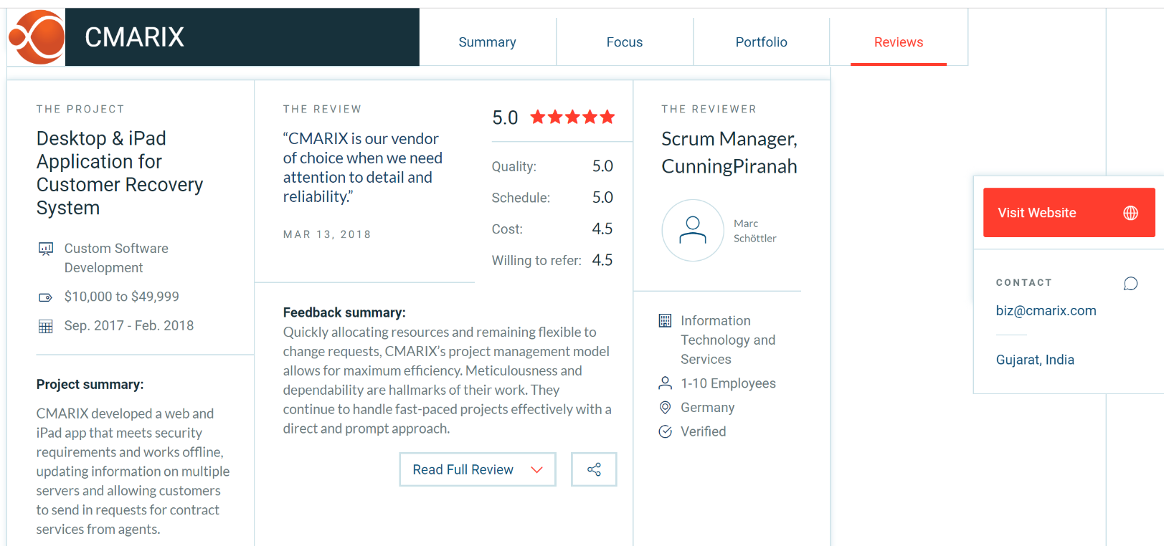

## Clutch Profile:

* To get more idea on the kind of projects which we have delivered, please refer to our clutch profile: <https://clutch.co/profile/cmarix>

# Project Purpose

The purpose of this project is to develop an AgriTech Web & Mobile Platform which will allow buyer to view different product and their details information and make an offer for particular product. Buyer can buy the product by making online payment. Seller should be able to register into the platform and manage their product and orders.

This project is for a create AgriTech Web & Mobile Platform Development which will be in English & Arabic language only. Moreover, the Frontend web platform will be responsive so it will be providing accessibility on mobile & tablet devices.



# Project Features

## Design Mockup

* 1. We will create a design UI/ UX Mockup for the Mobile Application as per the Standard.
  2. Design will be same for the both the platform for iPhone & Android Mobile. We have not consider the iPad & Android Tablet for the Design Mockup.
  3. We will create a design mock up for Frontend Web Platform.
  4. We will implement responsive design (Mobile and Tablet) accordingly to desktop design mock-up. We have not consider any separate design mockup creation for iPad and tablet for responsive web platform.
  5. Client will provide the name, logo and color palette for the design process

## Mind Map Web Platform (Buyer)

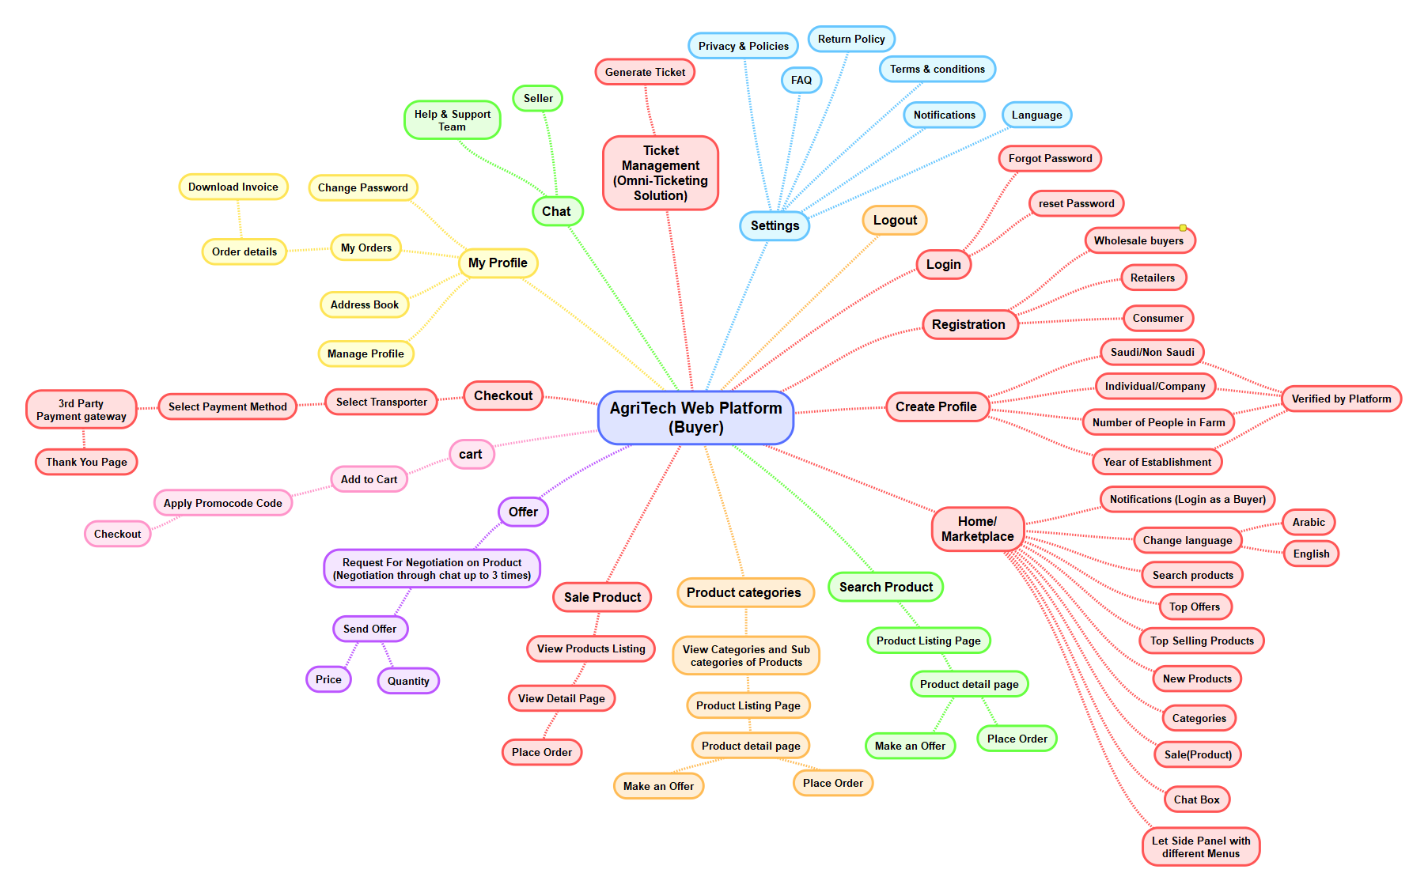

## Web Platform Features (Buyer)

1. **HOME PAGE** 
   1. **LOGO**: Logo that represent the brand identity of the company’s website. On click of logo from the any other page, it will navigate the Buyer to **“Home”** Page. Website Logo and Favicon Logo will be provided by the client.
   2. **TOP BAR** 
      1. Sign In
         1. Once the Buyer click on the sign in link, the system will navigate the Buyer to the “**Login**” page
      2. Change Language icon
         1. Once buyer click on change language icon, the system will display Arabic & English Language option. Once buyer select the particular language option the system will change all labels into selected language.
      3. Search Bar
         1. Buyer can search product related information by entering the keyword like product name, category, in the search fields and system will find all the related information that are matched with the entered keyword or name and display it into the search result page.
   3. **HEADER:** Header includes all the menu item with sub menu items:
      1. Home
      2. About
      3. Products
         1. Buyer should be able to view product category and their sub category in the menu.
      4. Contact Us
      5. Cart Icon
   4. **BANNER:** Buyer can view static banner image with some static text and button with respective link. On click of button, it will navigate the Buyer to “**Product**” page. Static Banner image and Static text will be provided by the client.
   5. **PRODUCT CATEGORY SECTION:** Buyer can view top 4 to 5 product category in this section, as follow:
      1. Category Name
      2. Category Image
         1. **Navigation:** Once buyer click on particular category, the system will navigate buyer their associated product listing page.
   6. **TOP SELLING PRODUCTS:** Buyer can view top 4 to 5 selling products in this sectionwith the below detail information in this section:
      1. Product Image
      2. Product Name
      3. Product Price
      4. Add to Cart Button
         1. Once buyer click on cart icon, the system will add that particular product into the shopping cart.
         2. Once buyer click on any product, system will navigate the buyer to “**Particular Product Detail**” page.
   7. **RECENTLY ADDED / NEW PRODUCTS:** Buyer can view top 4 to 5 new or recently added products in this section with the below detail information in this section:
      1. Product Image
      2. Product Name
      3. Product Price
      4. Add to Cart button
         1. Once buyer click on cart icon, the system will add that particular product into the shopping cart.
      5. Once buyer click on any product, system will navigate the Buyer to “**Particular Product Detail**” page.
   8. **A FOOTER WILL HAVE:**
      1. Quick Links like: Home, Product, Contact Us, and About Us.
      2. Other Links
         1. Terms and Conditions
         2. Privacy Policy
         3. FAQs
         4. Return Policy
      3. Social media Links such as (Facebook, Twitter, You Tube & Instagram)
      4. Company Address information along with the email address, contact number and fax
      5. Copyright text
2. **ABOUT US** 
   1. Buyer can view a banner image with the about us title on the top of this page
   2. Buyer to view detailed information about the organization with the following sections and their respective content detail:
      1. Organization Founder and History
      2. Organization Detail
      3. Our Mission
      4. Our Vision
3. **SEARCH** 
   1. Buyer can view search field at the top of the product listing page (Search Text box, Search Button)
   2. Buyer can search any product on this page by entering the product name, attributes, category, SKU and brand.
   3. Buyer can view their recent and popular search in the search box.
   4. The system will fetch all the product from the database and display on the product listing page and at that time the product listing page.
4. **CATEGORY LIST PAGE**
   1. Buyer can view different category list on this page with below details:
      1. Category Name
      2. Category Image
   2. **Navigation**: Once buyer click on particular category system will navigate buyer to their associated product listing page.
5. **PRODUCT LIST PAGE** 
   1. Buyer can view a Breadcrumb from the home page to current page under the banner image.
   2. When buyer select the category from the header menu, at that time they can view category title and all the products of that category on this page.
   3. Buyer can view all the list of the different category products in this page with the below details:
      1. Product Image
      2. Product Name
      3. Product Category
      4. Product Price
      5. Add to Cart Button
         1. Once Buyer click on cart icon, the system will add that particular product into the shopping cart.
   4. Once buyer click on any product, system will navigate the Buyer to **“Product Detail”** page.
   5. If the product have associated product options, at that time the add to cart button will not be display and buyer need to go to product detail page to add that product into the shopping cart.
   6. Buyer can view different filter option at the left side of product list page as below
   7. **Category / Sub Category:** 
      1. Buyer can view different category name in this section as below:
      2. Once buyer click or select any category name from the list and click on the apply button, the system will display all the list of the product based on the selected category.
   8. **Price**
      1. Buyer can add the minimum and maximum price value to filter.
      2. Once buyer select price range filter system will display related product list to buyer.
   9. **Brand**
      1. Buyer can view all the brand name on this section.
      2. Once buyer select the particular brand name, the system will display product to their associated brand to buyer.
   10. **Color**
       1. Buyer can view different color name in listing format.
       2. Once buyer choose particular color name on clicking of checkbox system will display related product to buyer.
   11. **Size**
       1. Buyer can view different size name in listing format.
       2. Once buyer choose particular size name on clicking of checkbox system will display related product to Buyer.
   12. Buyer can view sorting dropdown option at the top right side of the product listing page.
   13. Once buyer click on the sorting dropdown, the system will display following options to Buyer:
       1. Price: High to Low
       2. Price: Low to High
       3. Newest to Oldest
       4. Top Rated
       5. Most Viewed
   14. Based on the selected sorting option, the system will display related product to buyer.
   15. Buyer can view the pagination indexing on bottom of product listing page.
   16. **Navigation**: Once the Buyer click on the particular product name or image, the system will navigate the buyer to the “**Product Detail”** page.
6. **PRODUCT DETAIL PAGE** 
   1. Buyer can view a Breadcrumb from the Home page to current page under the banner image.
   2. Buyer can view particular product detail information on this page with the below details:
      1. Product Large Image
         1. Product Thumbnail Images (Multiple Images )
         2. Once the Buyer click on the thumbnail image, the system will display that image as a large image.
      2. Product Name
      3. Product SKU Code
      4. Product Category
      5. Product Price
      6. Product Size
      7. Product Color
      8. Based on selected product option, if any price variation then it will be display to the Buyer Image, description and all other parameter except the price will not be change on selection of the any product option.
      9. Add to Cart button
      10. Stock Availability
      11. Product Description
   3. Once buyer enter the quantity of the product and click on add to cart button, the system will add that particular product into the shopping cart.
   4. Buyer can view product review and ratting on this page.
   5. Buyer can add a review by entering below details:
      1. Ratting
      2. Review Description
      3. Submit Button
         1. Once Buyer enter the above details and click on submit button, system will store details into the database once admin will approve then it will display on product page.
   6. B2B buyer will be able to see different pricing for different package of product.
   7. **Make an Offer Button**
      * 1. Once buyer clicks on the make offer options, the system will allow the visitor to enter the below details.
           1. Offer Price
           2. Number of Quantity
           3. Description
           4. Send Button

Once the buyer enters the above details and clicks on the send button, the system will send an offer to the particular seller and send notification.

When a buyer sends an offer to a particular seller, the seller should be able to send the counteroffer to the buyer.

Make an offer process would be done only three time.

* 1. Buyer should be able to view chat icon on product detail page.
     1. **Navigation:** Once buyer click on chat icon, the system will navigate buyer to chat detail page from where buyer can do the live chat with seller.
  2. Buyer should be able to view the related product on bottom of this page with below details:
     1. Product Image
     2. Product Name
     3. Product Category
     4. Product Price
  3. **Navigation**: Once buyer click on particular product system will navigate Buyer to product detail page.

1. **SHOPPING CART PAGE**
   1. Buyer can view products that are added by them into the shopping cart on this page with the below details:
      1. Product Thumbnail Image
      2. Product Name
      3. SKU
      4. Product Category
      5. Product Price
      6. Selected Quantity
      7. Tax Amount
      8. Total Amount
   2. Buyer can view cart summary with subtotal, estimating shipping, estimated tax and discount.
   3. Buyer can either increase or decrease the particular product quantity from the available list.
   4. Buyer can remove the particular product from the available list by clicking on the remove link.
   5. Buyer can view the following two button at the bottom of the page.
      1. Continue Shopping
      2. Checkout
   6. Once buyer click on the continue shopping button, the system will navigate the Buyer to the “**Product List**” page.
   7. Once buyer click on the checkout button, the system will navigate buyer to the “**Checkout**” page.
2. **CHECKOUT PAGE**
   1. Once buyer comes to this page, the system will check that the buyer is login into the web platform account or not.
   2. If buyer is not logged in into the web platform, the system will navigate the buyer to the “**Login**” page after successfully login system will navigate buyer to checkout page.
   3. If buyer is logged in into the web platform, the system will allow buyer to enter the required information to purchase product from the web platform:
   4. **Billing Details:** 
      1. First Name
      2. Last name
      3. Company Name
      4. Country
      5. Street Address
      6. Town/ City Name
      7. State Name
      8. Zip Code
      9. Phone Number
      10. Email Address
   5. Check box for “Ship to different address?”
      1. If the buyer check the above checkbox then the buyer need to enter the below fields:
         1. First Name
         2. Last name
         3. Address
         4. Unit#/ Apartment Number
         5. Unit#/ Apartment Name
         6. Street/ Location Name
         7. Landmark
         8. Town/ City Name
         9. State Name
         10. Country
         11. Postal/ Zip Code
   6. Buyer can view a Your Order Summary Section with the below details:
      1. Product Name
      2. Product Category
      3. Product Price
      4. Sub Total
      5. Shipping Charges
      6. Service Charges
      7. Delivery Charges
      8. Total Amount
   7. Buyer can view total payable amount with bifurcation i.e. shipping charge, tax (if applicable)
   8. Buyer can view the Promo code field in the shopping page. Buyer can apply on one promo code at a time of checkout.
      1. Buyer can enter a promo code in this field.
      2. Once buyer enter a promo code and click on apply button, the system will check that the promo code is valid or not.
      3. If promo code is valid then the system will deduct a particular amount or percentage of amount from the order amount.
      4. If promo code is not valid then the system will display a “**Promo code is not valid**.” error validation message to buyer.
   9. Buyer should be able to select the logistic provider or partner details from the available list, as follow:
      1. Logistic Provider Name
      2. Logistic Provider Logo
      3. Logistic Provider Address
      4. Charge
      5. Delivery Time
   10. Buyer can make payment using the 3rd party PayPal Payment Gateway on the web platform.
   11. On click of payment system will redirect buyer to payment page.
   12. On successful payment, it will navigate the buyer to Thank you page along with continue shopping button which on click will redirect the Buyer to “**Home**” page.
   13. Buyer will receive an invoice email for the purchased product order.
3. **CONTACT US**
   1. Buyer can contact the administrator Buyer regarding any query by entering following form fields:
      1. Your First Name
      2. Your Last Name
      3. Your Email Address
      4. Your Phone Number
      5. Subject
      6. Message
   2. After entering the above information once the Buyer click on the send button, system will sent an email to the administrator with the above entered Buyer information.
   3. Apart from this buyer can view address, contact information of the organization or company.
   4. Buyer can view company or organization Address on Google Map with the location mark icon.
4. **LOGIN PAGE**
   1. Buyer should be able to see the below options to log in and access the platform.
   2. Buyer can login into the system by entering below details.
      1. Email address
      2. Password
      3. Login Button
         1. Once buyer enter the above details and click on login button, system will navigate buyer to Dashboard Page.
      4. Forgot Password:
         1. Once Buyer click on the forgot password link, system will navigate buyer to forgot password page.
      5. Registration:
         1. Once Buyer click on registration link system will navigate Buyer to sign up page.
5. **FORGOT PASSWORD**
   1. Buyer should be able to enter their email address to reset their credentials.
   2. Buyer can enter the following fields on this page to login reset their account credentials:
      1. Email Address
   3. **Reset button**: By clicking on the reset button, the system will send an email to the registered email address along with the reset password link. By clicking on the reset password link, the system will navigate the buyer to the Reset Password page.
6. **RESET PASSWORD**
   1. Buyer should be able to reset their account credentials.
   2. Buyer can enter the following fields on this page to reset their account credentials:
      1. New Password
      2. Confirm Password
   3. **Update button:** By clicking on the update button, the system will store the updated credentials in the database for the Buyer account and the system will navigate the Buyer to the “**Login**” page.
7. **REGISTRATION** 
   1. Buyer can register into the web platform by entering following form fields:
      1. **Normal Buyer:**
         1. First Name
         2. Last Name
         3. Email Address
         4. Mobile Number
         5. Password
         6. Confirm Password
      2. **B2B Buyer:**
         1. First Name
         2. Last Name
         3. Email Address
         4. Phone Number
         5. Upload Document
         6. Company Name
         7. Company Logo
         8. Company Address
         9. Company Phone Number
         10. Company Email Address
         11. Country
         12. Phone Number
         13. Password
         14. Confirm Password
   2. Once the buyer enter the value of the above field and click on submit button, the system will generate the new account for the buyer and the system will navigate the Buyer to “**Login**” Page.
   3. Once B2B, Retailers enter the above details and click on submit button system will store details into the database and once admin will approve theiraccount they will able to purchase the product through the platform.

1. **MY ACCOUNT**
   1. Buyer should be able to view following below menu on my account section:
      1. My Profile
      2. Edit Profile
      3. Change Password
      4. Chat
      5. Offer
      6. My Order
      7. Ticket Management
      8. Logout
   2. **Navigation**:
      1. Once buyer click on particular menu, the system will navigate buyer to their associated page.

1. **MY PROFILE** 
   * 1. Buyer can view and update his/her personal account information of the web platform in this section with the below details:
     2. **Normal Buyer:**
        1. First Name
        2. Last Name
        3. Email Address
        4. Mobile Number
     3. **B2B Buyer:**
        1. First Name
        2. Last Name
        3. Email Address
        4. Phone Number
        5. Upload Document
        6. Company Name
        7. Company Logo
        8. Company Address
        9. Company Phone Number
        10. Company Email Address
        11. Country
        12. Phone Number
     4. Edit Button
   1. Once Buyer click on the edit icon, the system will allow Buyer to edit above information. Once Buyer click on update icon and system will store details into database for particular Buyer.
2. **CHANGE PASSWROD**
   * 1. Buyer can change his/her web platform account credentials by entering the following form fields:
        1. Old Password
        2. New Password
        3. Confirm Password
     2. Once the Buyer enter the above information and click on the update button, system will update a new password for the particular Buyer account into the database and the system will navigate the Buyer to **“My Account”** Section. Also, Buyer has to remember the new password to login into their account.
3. **MY ORDERS** 
   * 1. Buyer can view all the list of orders that are placed by themselves on the web platform with the respective status & below details:
        1. Order Id
        2. Order Date
        3. Product Name
        4. Product Category
        5. Product Price
        6. Total Number of Quantity
        7. Total Amount Paid
        8. Order Status
           1. Pending
           2. In Progress
           3. Completed
           4. Cancelled
     2. Buyer can give rating and review for the particular product once they purchased the product on the web platform by entering the below details
        1. Rating
        2. Review
     3. Once Buyer enter the above detail and click on the submit button, the system will store all the information into the database and the system will display that particular Buyer review on that product details page.
4. **CHAT LISTING** 
   * 1. Buyer should be able to view all list of seller that they have chatted previously in this page.
     2. Buyer can view all list of seller with whom they have chatted previously in this page with below details:
        1. Seller Profile Photo
        2. Seller Name
        3. Seller Status
           1. Online
           2. Offline
        4. Last message
        5. Last Message Received Date & Time
     3. **Navigation:**
        1. Once buyer click on particular seller, the system will navigate buyer to the Chat Detail page.
5. **CHAT DETAIL** 
   * 1. Buyer should be able to communicate with the particular seller through this page.
     2. Buyer can view and previous chat with the particular seller in this page:
        1. Seller Profile Photo
        2. Seller Name
        3. Seller Status
           1. Online
           2. Offline
        4. All Chat Messages
        5. Chat Input Box
           1. Through this section, the seller can only send a text messages to the Seller.
     3. **Note**:
        1. For the chatting functionality, we will integrate the Google Firebase chat into the application.
        2. Client will provide all the details regarding to the Google Firebase Chat.
        3. We have not consider Image, Document, file, GIFs, Video sending functionality for the chat features.
6. **SUPPORT TICKET MANAGEMENT**
   1. Buyer should be able to view all the created ticket on this section, with below details:
      1. Ticket Number
      2. Issue Type
      3. Ticket Title
      4. Ticket Description
      5. Created Date & Time
      6. Current Status
         1. Pending
         2. In Progress
         3. Resolved
      7. Action
         1. Edit
         2. Cancel
   2. Buyer should be able to edit the created ticket on clicking of edit button.
   3. Buyer should be able to cancel the created ticket on clicking of cancel button.
   4. Buyer should be able to view create a new ticket button on this section.
   5. Buyer should be able to enter following details to create a new ticket:
      1. Issue Type (Dropdown)
      2. Ticket Title
      3. Ticket Description
      4. Create Button
   6. Once buyer enter the value of above fields and click on create button, the system will generate a new ticket and send it to support team.
7. **ADDRESS BOOK** 
   1. Buyer can their different address on this section.
   2. Buyer can view following address on this section:
      1. Default Billing Address
      2. Default Shipping Address
   3. Buyer can a new address by enter below details:
      1. House No
      2. Address
      3. City
      4. Country
      5. Telephone Number
      6. Make it
         1. Shipping Address
         2. Billing Address
      7. Add Button
      8. Once Buyer enter the above details and select the appropriate option system will consider that address and display here.
8. **OFFER**
   1. Buyer should be able to receive all the offers which has send by seller on this section, with below details:
      1. Product Name
      2. Number of Quantity
      3. Price
      4. Send Revised Offer
         1. Number of Quantity
         2. Price
         3. Send Button
   2. Once buyer enter the above details and click on send button, the system will again send a counter offer to particular seller and send an email notification.
9. **NOTIFICATION SETTINGS** 
   1. Buyer should be able to view and receive the notification on this section.
   2. Seller will be able to enable/disable push notification settings from this section:
      1. When admin send a notification from backend admin panel (On/ Off Toggle)
      2. When Seller send a new message (On/ Off Toggle)
      3. When Seller Send Offer (On/ Off Toggle)
10. **HELP & FAQ**
    * 1. Buyer should be able to view all list of FAQ on this page.
      2. Buyer can view all the list of the frequently asked questions with a down arrow or plus icon.
      3. Once buyer click on a particular question or down arrow icon, the system will display that particular question-answer with toggle effect.
      4. All the FAQ will be added and managed through the CMS by admin.
11. **LOGOUT**
    * 1. Once Buyer click on logout button system will logout Buyer from the account and will navigate to login page.

## Buyer Mobile Application Mind Map

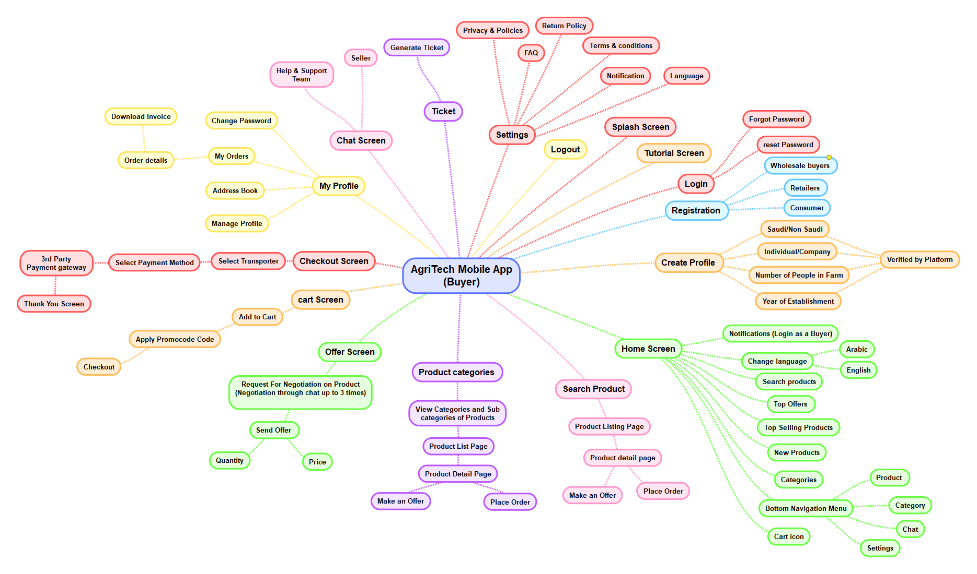

## Buyer Mobile Application

1. **SPLASH SCREEN**
   1. Buyer taps on app Icon to access application and their features.
   2. On the splash screen, buyer can view an application logo and name.
   3. The application logo represents the branding of the application.
   4. **Navigation**: After 2 or 3 seconds, Seller will automatically navigate to the "**Login**" screen. If buyer has already logged in to the Application then they will navigate directly to the “**Home**” screen.
2. **TUTORIAL SCREEN** 
   1. Buyer should be able to view Welcome text with image/Logo about application.
   2. Buyer can view tutorial screen regarding application information for the first time only.
   3. Seller can view 2 or 3 tutorial screen on the application with below details:
      1. App Title
      2. Image
      3. Some short description about the application
      4. Next Button
      5. Skip button
   4. **Navigation:** 
      1. On tap of next button, the system will display next tutorial screen. On last tutorial screen the next button will be hidden.
      2. On tap of skip button, the system will navigate buyer to the login screen.
   5. **Note:** 
      1. All content and images that are display on tutorial screen will be provided by client.
      2. Buyer should able to view welcome screen only once when he/she come into the app first time.
3. **LOGIN SCREEN**
   1. Buyer should be able to login into the Application.
   2. Buyer can enter the following fields to login into the Application:
      1. Email Address
      2. Password
      3. **Login button**: By tapping on login button, the system will check credentials and if all credentials are correct then the system will navigate buyer to the “**Home**” screen.
      4. **Forgot Password**: By tapping on forgot password link, the system will navigate buyer to the “Forgot Password” screen.
      5. Not have an account? Sign Up Link
         1. By tapping on sign up link, the system will navigate the buyer to the Registration Screen.
4. **FORGOT PASSWORD**
   1. Buyer should be able to enter their email address to reset their account credentials.
   2. Buyer can enter the following fields on this screen to login into the application:
      1. Email Address/ Phone Number
      2. Reset button
      3. **Navigation**: By tapping on the reset button, the system will send an email on the registered email address / mobile number along with OTP (4- or 6-digit OTP) and system will navigate buyer to the **Reset Password** Screen.
5. **RESET PASSWORD**
   1. Buyer should be able to reset their Account’s credentials with the following details”
      1. Enter OTP
      2. Verify OTP button
         1. Buyer need to enter the OTP that they have received on email address.
         2. Once buyer enters OTP, the system will check that entered OTP is correct or not.
         3. If OTP is correct, system will allow buyer to enter other required fields.
         4. If OTP is incorrect, system will display an error message to buyer.
      3. New Password (Password Field): Placeholders shall be included
      4. Confirm Password (Password Field): Placeholder shall be included
      5. Reset (button)
   2. **Navigation**: Once buyer enters value of the above fields and tap on reset button, the system will store this data into the database for the particular buyer account and the system will navigate buyer to the "**Login**" screen.
6. **REGISTRATION SCREEN** 
   1. Buyer should be able to register into the application by entering below details:
   2. Buyer should be able to select buyer type, which will be as follow below:
      1. Consumer
      2. B2B Buyer
   3. Once buyer select any one option from above, based on selection the system will display registration form to buyer.
      1. **Normal Buyer:**
         1. First Name
         2. Last Name
         3. Email Address
         4. Mobile Number
         5. Password
         6. Confirm Password
      2. **B2B Buyer:**
         1. First Name
         2. Last Name
         3. Email Address
         4. Phone Number
         5. Upload Document
         6. Company Name
         7. Company Logo
         8. Company Address
         9. Company Phone Number
         10. Company Email Address
         11. Country
         12. Phone Number
         13. Password
         14. Confirm Password
   4. Once the buyer enter the value of the above field and tap on submit button, the system will generate the new account for the buyer and the system will navigate the Buyer to “**Login**” screen.
   5. Once B2B, enter the above details and tap on submit button system will store details into the database and once admin will approve their account they will able to purchase the product through the platform.
7. **HOME SCREEN** 
   1. Buyer should be able to view application logo on home screen.
   2. Buyer should be able to view search box on home screen. Buyer can search product related information by entering the keyword like product name, category, in the search fields and system will find all the related information that are matched with the entered keyword or name and display it into the search result Screen.
   3. Buyer can view notification icon on home screen.
   4. Buyer can view cart icon on home screen.
   5. Buyer can view banner images on home screen, with sale and discount details.
   6. **Product Category Section:**
      1. Buyer can view top 4 to 5 product category in home screen, as follow:
         1. Category Name
         2. Category Image
         3. **Navigation**: Once buyer tap on particular category system will navigate Buyer their associated product listing Screen.
   7. **Top Selling Products:** 
      1. Buyer can view top 4 to 5 selling products on home screen with the below detail information:
         1. Product Image
         2. Product Name
         3. Product Price
         4. Add to Cart Button
         5. Once the buyer tap on cart icon, the system will add that particular product into the shopping cart.
         6. Once the buyer tap on any product, system will navigate the buyer to “**Particular Product Detail**” Screen.
   8. **Recently Added / New Products:** 
      1. Buyer can view top 4 to 5 new or recently added products in this section with the below detail information:
         1. Product Image
         2. Product Name
         3. Product Price
         4. Add to Cart button
         5. Once the buyer tap on cart icon, the system will add that particular product into the shopping cart
      2. Once the buyer tap on any product, system will navigate the Buyer to “**Particular Product Detail**” Screen.
   9. **Bottom Navigation Menu:**
      1. Buyer should be able to view following below bottom bar menu on home screen:
         1. Home
         2. Product
         3. Category
         4. Chat
         5. Setting
      2. Buyer should be able to view following below menu on home screen:

1. **CATEGORY LIST SCREEN**
   1. Buyer can view different category list on this Screen with below details:
      1. Category Name
      2. Category Image
   2. **Navigation**: Once Buyer tap on particular category system will navigate buyer to their associated product listing Screen.
2. **PRODUCT LIST SCREEN** 
   1. Buyer can view a Breadcrumb from the home Screen to current Screen under the banner image.
   2. When the Buyer select the category from the header menu, at that time they can view category title and all the products of that category on this Screen.
   3. Buyer can view all the list of the different category products in this Screen with the below details:
      1. Product Image
      2. Product Name
      3. Product Category
      4. Product Price
      5. Add to Cart Button
         1. Once the buyer tap on cart icon, the system will add that particular product into the shopping cart.
   4. Once the Buyer tap on any product, system will navigate the Buyer to **“Product Detail”** Screen.
   5. If the product have associated product options, at that time the add to cart button will not be display and Buyer need to go to product detail Screen to add that product into the shopping cart.
   6. Buyer can view different filter option at the left side of product list Screen as below:
   7. **Category / Sub Category:** 
      1. Buyer can view different category name in this section as below:
      2. Once the Buyer tap or select any category name from the list and tap on the apply button, the system will display all the list of the product based on the selected category.
   8. **Price**
      1. Buyer can add the minimum and maximum price value to filter.
      2. Once Buyer select price range filter system will display related product list to Buyer.
   9. **Brand**
      1. Buyer can view all the brand name on this section.
      2. Once buyer select the particular brand name, the system will display product to their associated brand to buyer.
   10. **Color**
       1. Buyer can view different color name in listing format.
       2. Once Buyer choose particular color name on taping of checkbox system will display related product to Buyer.
   11. **Size**
       1. Buyer can view different size name in listing format.
       2. Once Buyer choose particular size name on taping of checkbox system will display related product to Buyer.
   12. Buyer can view sorting dropdown option at the top right side of the product listing Screen.
   13. Once the Buyer tap on the sorting dropdown, the system will display following options to Buyer:
       1. Price: High to Low
       2. Price: Low to High
       3. Newest to Oldest
       4. Top Rated
       5. Most Viewed
   14. Based on the selected sorting option system will display related product to Buyer.
   15. Once the Buyer tap on the particular product name or image, the system will navigate the Buyer to the “**Product Detail**” Screen.
3. **PRODUCT DETAIL SCREEN** 
   1. Buyer can view back arrow icon on this screen.
   2. Buyer can view particular product detail information on this Screen with the below details:
      1. Product Large Image
         1. Product Thumbnail Images (Multiple Images )
         2. Once the Buyer tap on the thumbnail image, the system will display that image as a large image. (Zoom in on product image)
      2. Product Name
      3. Product SKU Code
      4. Product Category
      5. Product Price
      6. Product Size
      7. Product Color
         1. Based on selected product option, if any price variation then it will be display to the Buyer Image, description and all other parameter except the price will not be change on selection of the any product option.
      8. Add to Cart button
      9. Stock Availability
      10. Product Description
   3. Once the buyer enter the quantity of the product and tap on add to cart button, the system will add that particular product into the shopping cart.
   4. Buyer can view product review and ratting on this Screen.
   5. Buyer can add a review by entering below details:
      1. Ratting
      2. Review Description
      3. Submit Button
         1. Once Buyer enter the above details and tap on submit button, system will store details into the database once admin will approve then it will display on product Screen.
   6. B2B will see different pricing for different package of product.
   7. Retailers will see different pricing for different package of product.
   8. Make an Offer Button
      1. **Navigation:** Buyer should be able to view chat icon on product detail Screen.
   9. Chat icon Or Button:
      1. **Navigation:** Once buyer tap on chat icon, the system will navigate buyer to chat detail Screen from where buyer can do the live chat with seller.
   10. Buyer should be able to view the related product on bottom of this Screen with below details:
       1. Product Image
       2. Product Name
       3. Product Category
       4. Product Price
   11. **Navigation**: Once buyer tap on particular product, the system will navigate buyer to product detail Screen.
   12. **Back Icon**: Once buyer tap on back arrow icon, the system will navigate buyer to previous screen.
4. **MAKE AN OFFER SCREEN**
   1. Buyer can view back arrow icon on this screen.
   2. Buyer can send counter offer to particular seller through this screen.
   3. Buyer should be able to enter following below details to send an offer to seller:
      1. Offer Price
      2. Number of Quantity
      3. Description
      4. Send Button
         1. Once the buyer enters the above details and taps on the send button, the system will send an offer to the particular seller and send notification.
         2. When a buyer sends an offer to a particular seller, the seller should be able to send the counteroffer to the buyer.
         3. Make an offer process would be done only three time.
   4. **Back icon**: Once buyer tap on back arrow icon, the system will navigate buyer to previous screen.
5. **SHOPPING CART SCREEN**
   1. Buyer can view back arrow icon on this screen.
   2. Buyer can view products that are added by them into the shopping cart on this Screen with the below details:
      1. Product Thumbnail Image
      2. Product Name
      3. SKU
      4. Product Category
      5. Product Price
      6. Selected Quantity
      7. Tax Amount
      8. Total Amount
   3. Buyer can view cart summary with subtotal, estimating shipping, estimated tax and discount.
   4. Buyer can either increase or decrease the particular product quantity from the available list.
   5. Buyer can remove the particular product from the available list by taping on the remove link.
   6. Buyer can view the following two button at the bottom of the Screen.
      1. Continue Shopping
      2. Checkout
   7. **Navigation**:
      1. Once the buyer tap on the continue shopping button, the system will navigate the Buyer to the “**Product List**” Screen.
      2. Once the buyer tap on the checkout button, the system will navigate buyer to the “**Checkout**” Screen.
      3. **Back Icon**: Once buyer tap on back arrow icon, the system will navigate buyer to previous screen.
6. **CHECKOUT SCREEN**
   1. Buyer can view back arrow icon on this screen.
   2. Once the buyer comes to this Screen, the system will check that the buyer is login into the web platform account or not.
   3. If the buyer is not logged in into the web platform, the system will navigate the buyer to the “Login” Screen after successfully login system will navigate buyer to checkout Screen.
   4. If the buyer is logged in into the web platform, the system will allow buyer to enter the required information to purchase product from the web platform:
   5. **Billing Details:**
      1. First Name
      2. Last name
      3. Company Name
      4. Country
      5. Street Address
      6. Town/ City Name
      7. State Name
      8. Zip Code
      9. Phone Number
      10. Email Address
   6. Check box for “Ship to different address?”
   7. If the buyer check the above checkbox then the buyer need to enter the below fields:
      1. First Name
      2. Last name
      3. Address
      4. Unit#/ Apartment Number
      5. Unit#/ Apartment Name
      6. Street/ Location Name
      7. Landmark
      8. Town/ City Name
      9. State Name
      10. Country
      11. Postal/ Zip Code
   8. Buyer can view a Your Order Summary Section with the below details:
      1. Product Name
      2. Product Category
      3. Product Price
      4. Sub Total
      5. Shipping Charges
      6. Service Charges
      7. Delivery Charges
      8. Total Amount
   9. Buyer can view total payable amount with bifurcation i.e. shipping charge, tax (if applicable)
   10. Buyer can view the Promo code field in the shopping Screen. Buyer can apply on one promo code at a time of checkout.
       1. Buyer can enter a promo code in this field.
       2. Once buyer enter a promo code and tap on apply button, the system will check that the promo code is valid or not.
       3. If promo code is valid then the system will deduct a particular amount or percentage of amount from the order amount.
       4. If promo code is not valid then the system will display a “**Promo code is not valid**.” error validation message to buyer.
   11. Buyer should be able to select the logistic provider or partner details from the available list, as follow:
       1. Logistic Provider Name
       2. Logistic Provider Logo
       3. Logistic Provider Address
       4. Charge
       5. Delivery Time
   12. On tap of payment system will redirect buyer to payment Screen.
   13. On successful payment, it will navigate the buyer to Thank you Screen along with continue shopping button which on tap will redirect the Buyer to “**Home**” Screen.
   14. Buyer will receive an invoice email for the purchased product order.
7. **THANK YOU SCREEN**
   1. Buyer should be able to view a thank you message on this screen.
   2. Buyer can view thanks message on this screen along with the right mark icon and Go to Home button.
   3. Once Buyer tap on go to home button, the system will navigate the Buyer to the Home screen.
8. **MY ACCOUNT**
   1. Buyer should be able to view following below menu on my account section:
      1. My Profile
      2. Edit Profile
      3. My Order
      4. Change Password
      5. Setting
         1. Change Language
         2. Term and conditions
         3. Privacy and Policy
         4. Delete Account
         5. FAQs
         6. Return Policy
      6. Chat
      7. Offer
      8. Ticket Management
      9. Logout
   2. **Navigation**:
      1. Once buyer tap on particular menu, the system will navigate buyer to their associated Screen.

1. **MY PROFILE/ EDIT** 
   1. Buyer can view back arrow icon on this screen.
   2. Buyer can view and update his/her personal account information of the web platform in this section with the below details:
   3. **Consumer Buyer:**
      1. First Name
      2. Last Name
      3. Email Address
      4. Mobile Number
   4. **B2B Buyer:**
      1. First Name
      2. Last Name
      3. Email Address
      4. Upload Document
      5. Company Name (Can’t Change)
      6. Company Address (Can’t Change)
      7. Company Phone Number (Can’t Change)
      8. Company Email Address (Can’t Change)
      9. Country
      10. Phone Number
   5. **Retailers:**
      1. First Name
      2. Last Name
      3. Email Address
      4. Business Name (Can’t Change)
      5. Document (Can’t Change)
      6. Country
      7. Phone Number
      8. Edit Button
   6. Once buyer tap on the edit icon, the system will allow Buyer to edit above information. Once Buyer tap on update icon and system will store details into database for particular Buyer.
   7. **Back icon:** Once buyer tap on back arrow icon, the system will navigate buyer to previous screen.
2. **CHANGE PASSWROD**
   1. Buyer can view back arrow icon on this screen.
   2. Buyer can change his/her web platform account credentials by entering the following form fields:
      1. Old Password
      2. New Password
      3. Confirm Password
   3. Once the Buyer enter the above information and tap on the update button, system will update a new password for the particular Buyer account into the database and the system will navigate the Buyer to **“My Account”** Section. Also, Buyer has to remember the new password to login into their account.
   4. **Back icon:** Once buyer tap on back arrow icon, the system will navigate buyer to previous screen.
3. **MY ORDERS** 
   1. Buyer can view all the list of orders that are placed by themselves on the web platform with the respective status & below details:
      1. Order Id
      2. Order Date
      3. Product Name
      4. Product Category
      5. Product Price
      6. Total Number of Quantity
      7. Total Amount Paid
      8. Order Status
         1. Pending
         2. In Progress
         3. Completed
         4. Cancelled
   2. Buyer can give rating and review for the particular product once they purchased the product on the web platform by entering the below details:
      1. Rating
      2. Review
   3. Once Buyer enter the above detail and tap on the submit button, the system will store all the information into the database and the system will display that particular Buyer review on that product details Screen.
4. **CHAT LISTING SCREEN**
   1. Buyer should be able to view all list of seller that they have chatted previously in this screen.
   2. Buyer can view a back arrow icon on this screen.
   3. Buyer can view all list of buyer with whom they have chatted previously in this screen with below details:
      1. Seller Profile Photo
      2. Seller Name
      3. Seller Status
         1. Online
         2. Offline
      4. Last message
      5. Last Message Received Date & Time
   4. **Navigation:** 
      1. Once buyer tap on particular seller, the system will navigate buyer to the Chat Details Screen.
      2. Once buyer tap on back arrow icon, the system will navigate buyer to the “**Previous”** screen.
5. **CHAT DETAIL SCREEN** 
   1. Buyer should be able to communicate with the particular seller through this screen.
   2. Buyer can view a back arrow icon on this screen.
   3. Buyer can view and chat with the particular seller in this screen:
      1. Seller Profile Photo
      2. Seller Name
      3. Seller Status
         1. Online
         2. Offline
      4. All Chat Messages
      5. Chat Input Box
         1. Through this section, the buyer can only send a text messages to the seller.
   4. **Navigation**:
      1. Once buyer tap on back arrow icon, system will navigate buyer to the “**Previous”** screen.
   5. **Note**:
      1. For the chatting functionality, we will integrate the Google Firebase chat into the application.
      2. Client will provide all the details regarding to the Google Firebase Chat.
      3. We have not consider Image, Document, file, GIFs, Video sending functionality for the chat features.
6. **SUPPORT TICKET** 
   1. Buyer should be able to view all the created ticket on this section, with below details:
      1. Ticket Number
      2. Issue Type
      3. Ticket Title
      4. Ticket Description
      5. Created Date
      6. Current Status
         1. Pending
         2. In Progress
         3. Resolved
      7. Action
         1. Edit
         2. Cancel
   2. Buyer should be able to edit the created ticket on taping of edit button.
   3. Buyer should be able to cancel the created ticket on taping of cancel button.
   4. Buyer should be able to view create a new ticket button on this section.
   5. **Navigation:**
      1. Once buyer tap on create a new ticket button, the system will navigate buyer to create a new ticket screen.
      2. **Back icon**: Once buyer tap on back arrow icon, the system will navigate buyer to previous screen.
7. **CREATE A NEW TICKET**
   1. Buyer can view back arrow icon on this screen.
   2. Buyer should be able to enter following details to create a new ticket:
      1. Issue Type (Dropdown)
      2. Ticket Title
      3. Ticket Description
      4. Create Button
   3. Once buyer enter the value of above fields and tap on create button, the system will generate a new ticket and send it to support team.
   4. **Back icon:** Once buyer tap on back arrow icon, the system will navigate buyer to previous screen.
8. **ADDRESS BOOK** 
   1. Buyer can view back arrow icon on this screen.
   2. Buyer can their different address on this section.
   3. Buyer can view create a new address book button on this screen.
   4. Buyer can view following address on this section:
      1. Default Billing Address
      2. Default Shipping Address
   5. Buyer can view following below details on address book:
      1. House No
      2. Address
      3. City
      4. Country
      5. Telephone Number
      6. Make it
         1. Shipping Address
         2. Billing Address
   6. **Navigation:**
   7. Once buyer tap on crate a new address button, the system will navigate buyer to previous screen.
   8. **Back icon:** Once buyer tap on back arrow icon, the system will navigate buyer to previous screen.
9. **CREATE A NEW ADDRESS**
   1. Buyer can view back arrow icon on this screen.
   2. Buyer can a new address through this screen by entering below details:
      1. House No
      2. Address
      3. City
      4. Country
      5. Telephone Number
      6. Make it
         1. Shipping Address
         2. Billing Address
      7. Add Button
      8. Once Buyer enter the above details and select the appropriate option system will consider that address and display here.
   3. **Back icon:** Once buyer tap on back arrow icon, the system will navigate buyer to previous screen.
10. **OFFER**
    1. Buyer can view back arrow icon on this screen.
    2. Buyer should be able to receive all the offers which has send by seller on this section, with below details:
       1. Product Name
       2. Number of Quantity
       3. Price
       4. Send Revised Offer
          1. Number of Quantity
          2. Price
          3. Send Button
    3. Once buyer enter the above details and tap on send button, the system will again send a counter offer to particular seller and send an email notification.
    4. **Back icon:** Once buyer tap on back arrow icon, the system will navigate buyer to previous screen.
11. **NOTIFICATION SETTINGS** 
    1. Buyer should be able to view back arrow icon on this screen.
    2. Buyer should be able to view and receive the notification on this section.
    3. Buyer will be able to enable/disable push notification settings from this section:
       1. When admin send a notification from backend admin panel (On/ Off Toggle)
       2. When Seller send a new message (On/ Off Toggle)
       3. When Seller Send Offer (On/ Off Toggle)
12. **HELP & FAQ**
    1. Buyer should be able to view back arrow icon on this screen.
    2. Buyer should be able to view all list of FAQ on this Screen.
    3. Buyer can view all the list of the frequently asked questions with a down arrow or plus icon.
    4. Once buyer tap on a particular question or down arrow icon, the system will display that particular question-answer with toggle effect.
    5. All the FAQ will be added and managed through the CMS by admin.
    6. **Back icon**: Once buyer tap on back arrow icon, the system will navigate buyer to previous screen.
13. **CHANGE LANGUAGE SCREEN**
    1. Buyer should be able to change particular language of the application on this screen.
    2. Buyer can view below options for the language selection on this screen:
       1. English
       2. Arabic
    3. Buyer can select any one option from the available options.
    4. By default, English language is application default language.
    5. **Navigation**:
       1. Once seller select particular language option, system will display all the labels of the application in to the selected language.
14. **RETURN POLICY SCREEN** 
    1. Buyer should be able to read return policy of the application.
    2. Buyer can view a back arrow Icon on this screen.
    3. Buyer can view return policy of the application in this screen.
    4. **Navigation**: Once buyer tap on back arrow icon, system will navigate seller to the "My Account" Screen.
    5. **Note**:
       1. All the content of the privacy policy will be provided by the client.
       2. All the content will be added and managed from the administrator from Admin panel.
15. **PRIVACY POLICY SCREEN** 
    1. Buyer should be able to read privacy policy of the application.
    2. Buyer can view a back arrow Icon on this screen.
    3. Buyer can view privacy policy of the application in this screen.
    4. **Navigation**: Once buyer tap on back arrow icon, system will navigate seller to the "My Account" Screen.
    5. **Note**:
       1. All the content of the privacy policy will be provided by the client.
       2. All the content will be added and managed from the administrator from Admin panel.
16. **TERMS & CONDITIONS SCREEN**
    1. Buyer should be able to read Terms & conditions of the application.
    2. Buyer can view a Back arrow Icon on this screen.
    3. Buyer can view terms and conditions of the application in this screen.
    4. **Navigation**: Once buyer tap on back arrow icon, system will navigate seller to the "My Account" Screen.
    5. **Note**:
       1. All the content of the terms & conditions will be provided by the client.
       2. All the content will be added and managed from the administrator from Admin panel.
17. **DELETE ACCOUNT** 
    1. Buyer should be able to delete their application account and all the data.
    2. Once buyer tap on delete account option, the system will open an alert popup box
    3. In alert popup box seller can view “Are you sure you want to delete this account? All your account related information will also get deleted.” message along with following two buttons:
       1. Confirm
       2. Cancel
    4. **Navigation**:
       1. By tapping on ‘confirm’ button, the system will delete that particular buyer account from the database and all the data of this seller will also wiped out and the system will logged out buyer from the application and navigate buyer to the Login screen.
       2. By tapping on ‘**Cancel’** button, the system will close this screen and the system will navigate buyer to My Account screen.
18. **LOGOUT** 
    1. Buyer should be able to view logout button to close their account and secure it.
    2. **Navigation**:
       1. By tapping on this, the system will open a popup box where Buyer can view “Are you sure you want to logout?” message along with following two buttons
          1. Confirm
          2. Cancel
       2. By tapping on ‘confirm’ button, the system will logged out buyer from the application and navigate to **Login** screen.
       3. By tapping on ‘cancel’ button, the system will close this screen and the system will navigate buyer to the **My Account** screen.

## Seller Web Platform Mind Map

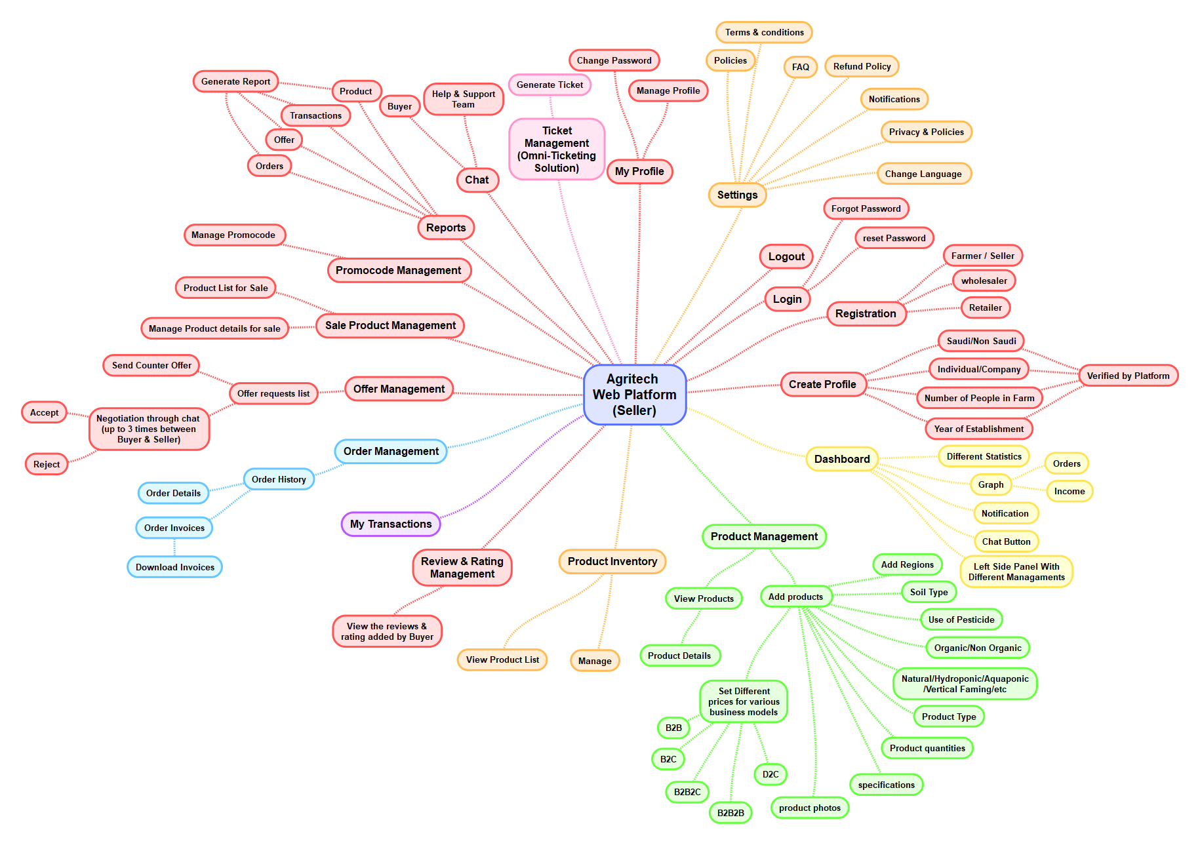

## Seller Web Platform

1. **LOGIN**
   1. Seller can login into the web platform by entering below details:
      1. Email Address
      2. Password
      3. Login Button
   2. Seller can view following options/ links on the Login page:
      1. Forgot password
      2. Not have an account? Sign up
   3. **Navigation**:
      1. Once seller click on the Forgot password link, the system will navigate the Seller to “**Forgot password**” page.
      2. Once seller click on the sign up link, the system will navigate the seller to “**Registration**” page.
2. **FORGOT PASSWORD**
   1. If seller forgot their web platform account credential then they can reset their account credential through forgot password section.
   2. Seller can view Enter Registered Email Address Field on this section.
   3. Seller can enter their web platform registered email address in this field.
   4. Once seller enter the email address and click on the reset password button, the system will send a reset password link on the above entered email address.
   5. Once seller click on the reset password link, the system will navigate the seller to “**Reset Password**” page.
3. **RESET PASSWORD**
   1. Seller can reset their web platform account credentials by entering the below form field:
      1. New Password
      2. Confirm-password
   2. Once seller enter the value of the above fields and click on the update button, the system will update a new password for the particular seller account into the database and the system will navigate the seller to the “**Login**” page.
4. **REGISTRATION**
   1. Seller can register into the web platform by entering following form fields:
      1. First Name
      2. Last Name
      3. Email Address
      4. Phone Number
      5. Seller Company Logo
      6. Seller Company Name
      7. Seller Company Email Address
      8. Seller Company Contact Number
      9. Seller Company Address
      10. Document
      11. Select Type
          1. Saudi
          2. Non- Saudi
      12. Number of people in farm
      13. Year of Established
      14. Password
      15. Confirm Password
      16. Checkbox for “I Accept all the Terms & Condition and Privacy Policy of the Web Platform”
   2. Once the seller enter the value of the above fields and click of the next button, the system will store all the information into the database and the system will navigate the seller to “**Dashboard**” page.
   3. Once seller enters and submit above information, the system will send an email notification to admin. Once admin will approved the seller account them system will allow seller to navigate into dashboard.
5. **DASHBOARD**
   1. Seller can view different statistics on the dashboard which will be as follow below:
      1. Total Number of Products
      2. Total Number of Orders
      3. Pending Orders
      4. In-progress Orders
      5. Cancelled Orders
      6. On Delivery Orders
      7. Completed Orders
   2. Seller can view left sidebar menu on the dashboard with below sections Link
      1. Dashboard
      2. Products Management
      3. Sale Product Management
      4. Order Management
      5. My Transaction
      6. Live Chat
      7. Ticket Management
      8. Product Inventory Management
      9. Offer Management
      10. Transaction Management
      11. Promo Code Management
      12. Reports
      13. Setting
          1. Edit Profile
          2. Change Password
          3. Term & Conditions
          4. Privacy & Policy
          5. Refund Policy
          6. FAQs
          7. Logout
   3. Once seller click on the particular section, the system will navigate the seller to the respective page.
6. **PRODUCTS PAGE**
   1. Seller can view all the list of the products that are added by them on the web platform particular store wise in this section with the below details:
      1. Product Thumbnail Images
      2. Product Name
      3. Product SKU Code
      4. Product Category
      5. Product Price
         1. Seller should be able to manage the price for B2B buyer and consumer.
      6. Available Quantity
      7. Product Detail Information
         1. Here in this tab, seller can view product different attributes related information.
   2. Seller can update the particular product information of the particular store by click on the update icon/ button
   3. Seller can delete a particular product of a particular store from the available list by click on the delete icon/ button
   4. Seller can view a Add New Product button at the top right side of this page.
   5. Once Seller click on the Add New Product button, the system will navigate to the Add New Product page.
   6. Once the Buyer place any product order, that particular product quantity will be automatically decrease from the current quantity stock under a particular store.
7. **ADD NEW PRODUCT**
   1. Seller can add a new product by entering the below form field on this page.
      1. Product Images
      2. Product Name
      3. Product SKU Code
      4. Product Category
      5. Product Price
      6. Available Quantity
      7. Product Detail Information
   2. Once seller enters the value of above fields and click on the add product button, the system will add a new product into the platform and display it on the website.
8. **ORDERS MANAGEMENT**
   1. Seller can view all the list of orders that are placed by the different Buyers on the platform in this section with the below details:
      1. Order Id
      2. Order Date
      3. Product Name
      4. Product Category
      5. Product Price
      6. Seller Name
      7. Seller Email Address
      8. Seller Contact Number
      9. Total Number of Quantity
      10. Coupon Code
      11. Logistic Providers Details
      12. Total Amount Paid
      13. Status
          1. Pending
          2. In Progress
          3. Completed
          4. Cancelled
   2. Seller can accept or reject the particular order in this section
   3. Once seller reject the order, the system will send the email notification to the Buyer.
   4. Seller can change the status of the particular order from pending to in progress to on delivery to completed.
9. **TRANSACTION MANAGEMENT**
   1. Seller should be able to view all the transaction which buyer did on the platform on this section with below details:
      1. Transaction ID
      2. Transaction Date & Time
      3. Product Name
      4. Product Category
      5. Number of Quantity
      6. Buyer Information
         1. Full Name
         2. Email Address
         3. Phone Number
         4. Address
      7. Amount Paid
      8. Seller Profit Amount
10. **SALE PRODUCT MANAGEMENT**
    1. Seller can view all the list of the product which has published on the web platform.
    2. Seller can view following below tabs on this section:
       1. Product
       2. Sale
    3. Seller can view product section first on this section, with below details:
       1. Product Thumbnail Images
       2. Product Name
       3. Product SKU Code
       4. Product Category
       5. Product Price
       6. Available Quantity
       7. Product Detail Information
       8. Sell Product Checkbox
    4. Once seller drag the particular product, the system will move that particular product into sell section and display it on web platform.
    5. Seller can view all the sale product on sale section, with below details:
       1. Product Thumbnail Images
       2. Product Name
       3. Product Category
       4. Product Price
       5. Product Detail Information
       6. Sale Start Date
       7. Sale End Date
       8. Discount
       9. Sale Description
    6. Seller can do various activity such as update, view and delete on this section.
11. **CHAT LISTING** 
    1. Seller should be able to view all list of buyer that they have chatted previously in this page.
    2. Seller can view all list of buyer with whom they have chatted previously in this page with below details:
       1. Buyer Profile Photo
       2. Buyer Name
       3. Buyer Status
          1. Online
          2. Offline
       4. Last message
       5. Last Message Received Date & Time
    3. **Navigation:** 
       1. Once seller click on particular buyer, the system will navigate seller to the Chat Detail page.
12. **CHAT DETAIL** 
    1. Seller should be able to communicate with the particular buyer through this page.
    2. Seller can view and previous chat with the particular buyer in this page:
       1. Buyer Profile Photo
       2. Buyer Name
       3. Buyer Status
          1. Online
          2. Offline
       4. All Chat Messages
       5. Chat Input Box
          1. Through this section, the seller can only send a text messages to the buyer.
    3. **Note**:
       1. For the chatting functionality, we will integrate the Google Firebase chat into the application.
       2. Client will provide all the details regarding to the Google Firebase Chat.
       3. We have not consider Image, Document, file, GIFs, Video sending functionality for the chat features.
13. **TICKET MANAGEMENT**
    1. Seller should be able to view all the created ticket on this section, with below details:
       1. Ticket Number
       2. Issue Type
       3. Ticket Title
       4. Ticket Description
       5. Created Date
       6. Current Status
          1. Pending
          2. In Progress
          3. Resolved
       7. Action
          1. Edit
          2. Cancel
    2. Seller should be able to edit the created ticket on click of edit button.
    3. Seller should be able to cancel the created ticket on click of cancel button.
    4. Seller should be able to view create a new ticket button on this section.
    5. Seller should be able to enter following details to create a new ticket:
       1. Issue Type (Dropdown)
       2. Ticket Title
       3. Ticket Description
       4. Create Button
    6. Once seller enter the value of above fields and click on create button, the system will generate a new ticket and send it to support team.
14. **PRODUCT INVENTORY MANAGEMENT**
    1. Seller should be able to view and manage product inventory through this section.
    2. Seller can view each product wise stock on this section.
    3. Once order is placed on the frontend web platform for a particular order, then particular number of quantity will be deducted or decreased for a particular product.
    4. Seller should be able to view inventory after placing an order by buyer, seller can view the stock availability on this section. Seller can track the location, amount, pricing available from their business.
    5. Seller should be able to view and manage the following things:
       1. Stock Availability
       2. Product Quantity
       3. Inventory Configurations
15. **OFFERS MANAGEMENT** 
    1. Seller can view the offers which have been sent by the buyer for particular product on this page.
       1. Product Name
       2. Product Image
       3. Product Quaintly
       4. Current Price
       5. Buyer Offers Price
       6. Action
          1. Accept
          2. Rejected
       7. Counter Offer
          1. Enter the amount
          2. Send Button
    2. Once the seller accepts/rejects the offer which has been sent by the buyer, the system will send an email notification to buyer.
    3. Once the seller sends the counteroffer to the buyer, the system will send an email notification to the buyer.
    4. Buyers can also send a counteroffer to seller for particular product.
    5. Sellers can buyers can send the offer only three time they cannot send the offers to each other multiple times on the platform, once seller will send final product quantity with amount seller need to accept it or decline it.

1. **PROMO/ COUPON CODE MANAGEMENT**
   1. Seller can view all the list of promo code that are created by themselves in this section with below details:
      1. Promo Code Name
      2. Promo Code Description
      3. Promo Code
      4. Promo Code Expiry Date
      5. Discount Type
         1. Flat
         2. Percentage
   2. Seller can create a new promo code by entering the following form fields:
      1. Promo Code Name
      2. Promo Code Description
      3. Promo Code
      4. Promo Code Expiry Date
      5. Discount Type
         1. Flat
         2. Percentage
   3. Seller can update the particular Promo code’s information by click on update button/ icon.
   4. Seller can delete particular Promo code from the available list by click on delete button/ icon.
2. **REPORT**
   1. Seller can view and download following reports from this section:
      1. Sales/ Orders Report
      2. Most Purchased Product Report
      3. Total Income
      4. Product Report
      5. Sale Product Report
   2. Custom Date Range: Once seller click on this option, the system will display two fields as below:
      1. Start Date
      2. End Date
   3. Once seller select start date and end date using calendar and click on the report button, the system will generate a particular reports based on the selected date and display the data to the seller on this section.
3. **MY PROFILE SETTING** 
   1. Seller should be able to view their personal details on this section with below details:
      1. Profile Photo
      2. First Name
      3. Last Name
      4. Email Address
      5. Phone Number
      6. Seller Company Logo
      7. Seller Company Name
      8. Seller Company Email Address
      9. Seller Company Contact Number
      10. Seller Company Address
      11. Number of people in farm
      12. Year of Established
   2. Seller should be able to view their account verification status as verified on this section.
   3. Seller should be able to view edit button on this section.
   4. Once seller edit the above information and click on update button, the system will store updated information into the database for particular seller.
4. **CHANGE PASSWORD** 
   1. Seller can change the account credentials through this section.
   2. Seller should be able to enter following below details to change their account credentials:
      1. Old Password
      2. New Password
      3. Confirm Password
   3. Once the seller enter the above information and click on the update button, the system will update a new password for the particular seller account into the database and the system will navigate the seller to the “Setting” section.
5. **NOTIFICATION SETTINGS** 
   1. Seller should be able to view all the notification settings that they have changes for the application.
   2. Seller will be able to enable/disable push notification settings from this section:
      1. When admin send a notification from backend admin panel (On/ Off Toggle)
      2. When Buyer send a new message (On/ Off Toggle)
      3. When Buyer place Order (On/ Off Toggle)
      4. When Buyer Send Offer (On/ Off Toggle)
6. **TERM AND CONDITIONS**
   1. Seller should be able to view platform term and condition content on this section.
   2. All the content will be provided by client and managed from backend admin panel.
7. **PRIVACY & POLICY**
   1. Seller should be able to view platform privacy and policy content on this section.
   2. All the content will be provided by client and managed from backend admin panel.
8. **FAQs**
   1. Seller should be able to view FAQs content on this section.
   2. Seller can view all the list of the frequently asked questions with a down arrow or plus icon.
   3. Once seller click on a particular question or down arrow icon, the system will display that particular question answer with toggle effect.
   4. All the content will be provided by client and managed from backend admin panel.
9. **LOGOUT** 
   1. Once the seller click on the logout link/button, the system will log out the seller from the account and will navigate to the login page.

## Seller Mobile Application Mind Map

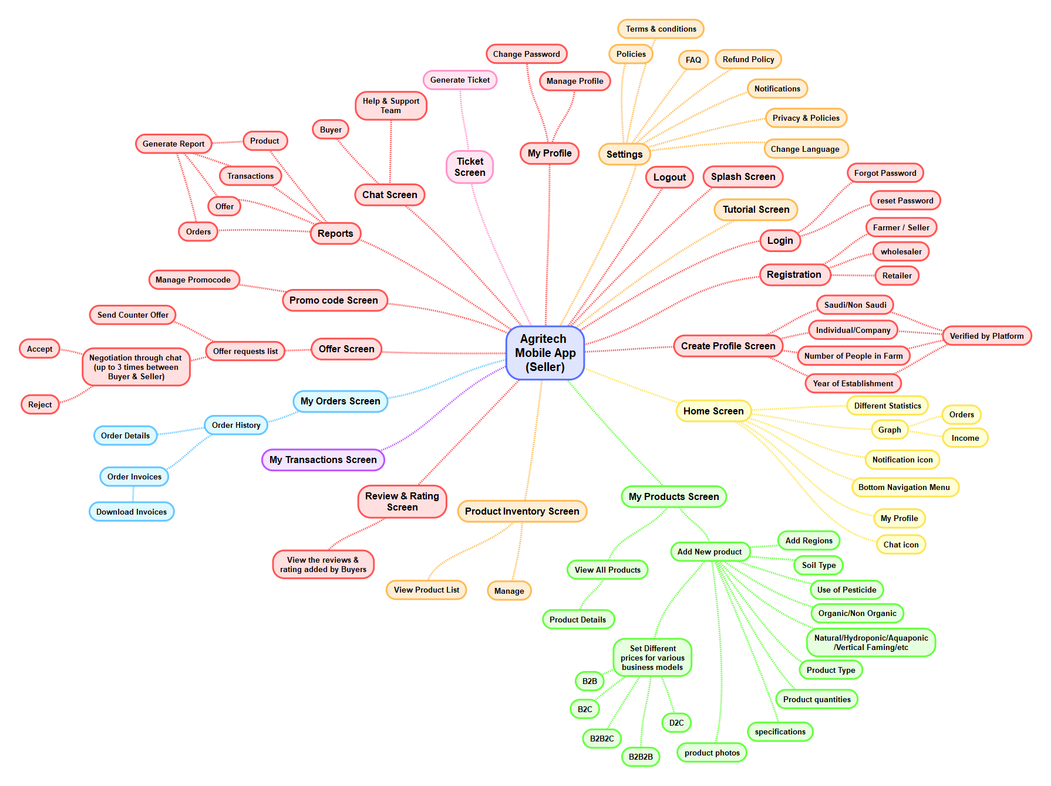

## Seller Mobile Application

1. **SPLASH SCREEN**
   1. Seller taps on app Icon to access application and their features.
   2. On the splash screen, Seller can view an application logo and name.
   3. The application logo represents the branding of the application.
   4. **Navigation**: After 2 or 3 seconds, Seller will automatically navigate to the "**Login**" screen. If Seller has already logged in to the Application then they will navigate directly to the “**Home**” screen.
2. **TUTORIAL SCREEN** 
   1. Seller should be able to view Welcome text with image/Logo about application.
   2. Seller can view tutorial screen regarding application information for the first time only.
   3. Seller can view 2 or 3 tutorial screen on the application with below details:
      1. App Title
      2. Image
      3. Some short description about the application
      4. Next Button
      5. Skip button
      6. **Navigation:** 
         1. On tap of next button, the system will display next tutorial screen. On last tutorial screen the next button will be hidden.
         2. On tap of skip button, the system will navigate seller to the login screen.
      7. **Note:** 
         1. All content and images that are display on tutorial screen will be provided by client.
         2. Seller should able to view welcome screen only once when he/she come into the app first time.
3. **LOGIN SCREEN**
   1. Seller should be able to login into the Application.
   2. Seller can enter the following fields to login into the Application:
      1. Email Address
      2. Password
      3. **Login button**: By tapping on login button, the system will check credentials and if all credentials are correct then the system will navigate Seller to the “Home/ Dashboard” screen.
      4. **Forgot Password**: By tapping on forgot password link, the system will navigate Seller to the “Forgot Password” screen.
      5. Not have an account? Sign Up Link
         1. By tapping on sign up link, the system will navigate the seller to the Registration Screen.
4. **FORGOT PASSWORD**
   1. Seller should be able to enter their email address to reset their backend credentials.
   2. Seller can enter the following fields on this screen to login into the backend Super Admin panel:
      1. Email Address or Mobile Number
      2. Reset button
      3. **Navigation**: By tapping on the reset button, the system will send an email on the registered email address / mobile number along with OTP (4- or 6-digit OTP) and system will navigate Seller to the **Reset Password** Screen.
5. **RESET PASSWORD**
   1. Seller should be able to reset their Account’s credentials with the following details”
      1. Enter OTP
      2. Verify OTP button
         1. Seller need to enter the OTP that they have received on email address.
         2. Once seller enters OTP, the system will check that entered OTP is correct or not.
         3. If OTP is correct, system will allow seller to enter other required fields.
         4. If OTP is incorrect, system will display an error message to seller.
      3. New Password (Password Field): Placeholders shall be included
      4. Confirm Password (Password Field): Placeholder shall be included
      5. Reset (button)
   2. **Navigation**: Once seller enters value of the above fields and tap on reset button, the system will store this data into the database for the particular seller account and the system will navigate seller to the "**Login**" screen.
6. **REGISTRATION SCREEN**
   1. Seller should be able to enter required information to create an account on application.
   2. Seller can enter the following fields to login into the Application:
      1. First Name
      2. Last Name
      3. Email Address
      4. Phone Number
      5. Seller Company Logo
      6. Seller Company Name
      7. Seller Company Email Address
      8. Seller Company Contact Number
      9. Seller Company Address
      10. Select Type
          1. Saudi
          2. Non- Saudi
      11. Number of people in farm
      12. Year of Established
      13. Password
      14. Confirm Password
      15. Checkbox for “I agree all the terms & conditions and privacy policy of the application.”
      16. Create Account
   3. **Navigation**:
      1. Once seller enters value of above fields and tap on create account button, the system will store all the data into the database and generate a new account of the seller and the system will navigate the seller to the “**Dashboard”** Screen.
      2. Once seller enters above details and submit information, the system will send an email notification to admin. Once admin will approved the seller account them system will allow seller to navigate into dashboard.
7. **DASHBOARD SCREEN**
   1. Seller should be able to view different statistics and graphs on the dashboard screen.
   2. Seller can view a notification icon on the dashboard screen
   3. Seller can view all the different statistics on the dashboard screen as below:
      1. Total Number of Products
      2. Total Number of Orders
      3. Pending Orders
      4. In-progress Orders
      5. Cancelled Orders
      6. On Delivery Orders
      7. Completed Orders
   4. Seller can view Stock Out Products monthly earning line graph related information in this section:
      1. Here seller can view below information on the graph
         1. Commission Earning
         2. Commission Given
         3. X = Income
         4. Y = Months
   5. Seller can view Chat with buyer on the dashboard screen with below details:
      1. Buyer Profile Picture
      2. Buyer Name
      3. Buyer Online/ Offline Status
      4. Last Received Message
      5. Last Received Message Date & Time
      6. View All Link
         1. On tap of view all link, system will navigate seller to the Chat Listing screen.
   6. **Bottom Navigation Menu Bar Section**:
      1. Seller can view following menu section with their respective icon in each screen of application:
         1. Home/ Dashboard
         2. My Orders
         3. Products
         4. Live Chat
         5. Support Ticket
      2. Seller should be able to view following below menu on dashboard screen:
         1. Transaction
         2. Product Inventory
         3. Offers
         4. Report
         5. Setting
      3. **Navigation**:
         1. Once seller tap on notification icon, the system will navigate seller to the “**Notification**” Screen
         2. Once seller tap on particular bottom menu bar icon, system will navigate seller to the associated screen.
         3. Once seller tap on any menu from dashboard screen, the system will navigate seller to their associated screen.
      4. **Note**:
         1. For graph view, we will integrate 3rd party Graph library into the mobile application. If graph library is purchasable then client will purchase it and provide us with all the necessary information.
8. **ORDERS SCREEN**
   1. Seller should be able to view all the order that they have received on the application.
   2. Seller can view a back arrow icon on this screen.
   3. Seller can view following filter tabs on this screen:
      1. All
      2. Pending
      3. Processing
      4. Delivered & Completed
      5. Cancelled
   4. Once seller a tap on a particular tab, the system will display all the data based on the selected tab.
   5. By default, ‘All’ tab is selected when seller comes to this screen.
   6. Seller can view all the order that are placed by different Buyer for their product on application in this section with below details:
      1. Order ID
      2. Order Date & Time
      3. Buyer Name
      4. Product Name
      5. Size
      6. Quantity
      7. Price
      8. Delivery
      9. Shipping Address
   7. **Navigation**:
      1. Once seller tap on particular order, system will navigate seller to the **Order Detail** screen.
      2. Once seller tap on back arrow icon, system will navigate seller to the previous screen.
9. **ORDER DETAIL SCREEN**
   1. Seller should be able to view particular order detail information on this screen.
   2. Seller can view a back arrow icon on this screen.
   3. Seller can view particular orders detail information on this screen with below details:
      1. Order ID
      2. Order Date & Time
      3. Method of Payment
      4. Payment Status
         1. Paid
         2. Unpaid
      5. Product Info
         1. Product Thumbnail Image
         2. Product Name
         3. Brand Name
         4. SKU Code
         5. Size
         6. Product Price
         7. Selected Quantity
      6. Total
         1. Sub Total
         2. Tax
         3. Coupon Discount Amount
         4. Logistic Providers Details
         5. Total Amount
      7. Buyer Details
         1. Buyer Name
         2. Buyer Email Address
         3. Buyer Contact Number
         4. Buyer Address
      8. Select order Status with dropdown menu
         1. Pending
         2. Processing
         3. Delivered & Completed
         4. Cancelled
      9. Submit button
   4. **Navigation**:
      1. Once seller tap on back arrow icon, system will navigate seller to the previous screen.
      2. Once seller tap on submit button, system will change the status of the particular order and the system will send notification to the particular buyer for status update.
10. **PRODUCTS SCREEN**
    1. Seller should be able to view all the product that they have received on the application.
    2. Seller can view a back arrow icon on this screen.
    3. Seller can view all the products that are added by them on application in this section with below details:
       1. Product Images
       2. Product Name
       3. Product SKU Code
       4. Product Category
       5. Product Price
          1. Seller should be able to manage the price for B2B buyer and consumer.
       6. Available Quantity
       7. Product Detail Information
       8. Actions
          1. Edit
          2. View
          3. Delete
    4. Seller can view a floating plus icon on this screen.
    5. **Navigation**:
       1. Once seller tap on back arrow icon, system will navigate seller to the previous screen.
       2. Once seller tap on edit icon, the system will navigate seller to the particular product edit screen where seller can update a particular product information.
       3. Once seller tap on view icon, the system will navigate seller to the particular product detail view screen.
       4. Once seller tap on delete icon, the system will open an alert popup box where seller can view “Are you Sure you want to delete this item?” with following two options:
          1. Confirm
          2. Cancel
       5. If seller taps on confirm button, the system will delete that particular product from the available list.
       6. If seller taps on cancel button, the system will close alert popup box.
       7. Once seller tap on floating plus icon, the system will navigate the seller to the Add new Product screen.
11. **ADD NEW PRODUCT SCREEN**
    1. Seller should be able to view enter required information to add new product on the application.
    2. Seller can view a back arrow icon on this screen.
    3. Seller can add a new product by entering the following form fields:
       1. Product Thumbnail Images
       2. Product Name
       3. Product SKU Code
       4. Product Category
       5. Product Price
       6. Available Quantity
       7. Product Detail Information
       8. Add Button
    4. **Navigation**:
       1. Once seller enters value of above fields and tap on add button, the system will store all the data into the database and generate a new product and the system will navigate seller to the Product listing screen where seller can view “**Product uploaded successfully**.” toast message.
       2. Once seller tap on back arrow icon, system will navigate seller to the previous screen.
12. **CHAT LISTING SCREEN** 
    1. Seller should be able to view all list of buyer that they have chatted previously in this screen.
    2. Seller can view a back arrow icon on this screen.
    3. Seller can view all list of buyer with whom they have chatted previously in this screen with below details:
       1. Buyer Profile Photo
       2. Buyer Name
       3. Buyer Status
          1. Online
          2. Offline
       4. Last message
       5. Last Message Received Date & Time
    4. **Navigation:** 
       1. Once seller tap on particular seller, the system will navigate seller to the Chat Details Screen.
       2. Once seller tap on back arrow icon, the system will navigate seller to the “**Previous”** screen.
13. **CHAT DETAIL SCREEN** 
    1. Seller should be able to communicate with the particular buyer through this screen.
    2. Seller can view a back arrow icon on this screen.
    3. Seller can view and chat with the particular buyer in this screen:
       1. Buyer Profile Photo
       2. Buyer Name
       3. Buyer Status
          1. Online
          2. Offline
       4. All Chat Messages
       5. Chat Input Box
          1. Through this section, the seller can only send a text messages to the buyer.
    4. **Navigation**:
       1. Once seller tap on back arrow icon, system will navigate seller to the “**Previous”** screen.
    5. **Note**:
       1. For the chatting functionality, we will integrate the Google Firebase chat into the application.
       2. Client will provide all the details regarding to the Google Firebase Chat.
       3. We have not consider Image, Document, file, GIFs, Video sending functionality for the chat features.
14. **TRANSACTION** 
    1. Seller can view back arrow icon on this screen.
    2. Seller should be able to view all the transaction which buyer did on the platform on this section with below details:
       1. Transaction ID
       2. Transaction Date & Time
       3. Product Name
       4. Product Category
       5. Number of Quantity
       6. Buyer Information
          1. Full Name
          2. Email Address
          3. Phone Number
          4. Address
       7. Amount Paid
       8. Seller Profit Amount
    3. **Back Arrow:** Onceseller tap on back arrow icon, the system will navigate seller to previous screen.
15. **SUPPORT TICKET** 
    1. Seller should be able to view all the created ticket on this section, with below details:
       1. Issue Type
       2. Ticket Title
       3. Ticket Description
       4. Created Date
       5. Current Status
          1. Pending
          2. In Progress
          3. Resolved
       6. Action
          1. Edit
          2. Cancel
    2. Seller should be able to edit the created ticket on taping of edit button.
    3. Seller should be able to cancel the created ticket on taping of cancel button.
    4. Seller should be able to view create a new ticket button on this section.
    5. **Navigation:**
       1. Once seller tap on create a new ticket button, the system will navigate seller to create a new ticket screen.
       2. **Back icon**: Once seller tap on back arrow icon, the system will navigate seller to previous screen.
16. **CREATE A NEW TICKET**
    1. Seller can view back arrow icon on this screen.
    2. Seller should be able to enter following details to create a new ticket:
       1. Issue Type (Dropdown)
       2. Ticket Title
       3. Ticket Description
       4. Create Button
    3. Once seller enter the value of above fields and tap on create button, the system will generate a new ticket and send it to support team.
    4. **Back icon:** Once seller tap on back arrow icon, the system will navigate seller to previous screen.
17. **PRODUCT INVENTORY** 
    1. Seller can view back arrow icon on this screen.
    2. Seller should be able to view and manage product inventory through this section.
    3. Seller can view each product wise stock on this section.
    4. Once order is placed on the frontend web platform for a particular order, then particular number of quantity will be deducted or decreased for a particular product.
    5. Seller should be able to view inventory after placing an order by buyer, seller can view the stock availability on this section. Seller can track the location, amount, pricing available from their business.
    6. Seller should be able to view and manage the following things:
       1. Stock Availability
       2. Product Quantity
       3. Inventory Configurations
    7. **Back icon**: Once seller tap on back arrow icon, the system will navigate seller to previous screen.
18. **OFFERS** 
    1. Seller can view back arrow icon on this screen.
    2. Seller can view the offers which have been sent by the buyer for particular product on this Screen.
       1. Product Name
       2. Product Image
       3. Product Quaintly
       4. Current Price
       5. Buyer Offers Price
       6. Action
          1. Accept
          2. Rejected
       7. Counter Offer
          1. Enter the amount
          2. Send Button
    3. Once the seller accepts/rejects the offer which has been sent by the buyer, the system will send an email notification to buyer.
    4. Once the seller sends the counteroffer to the buyer, the system will send an email notification to the buyer.
    5. Buyers can also send a counteroffer to seller for particular product.
    6. Sellers can buyers can send the offer only three time they cannot send the offers to each other multiple times on the platform, once seller will send final product quantity with amount seller need to accept it or decline it.
    7. **Back icon**: Once seller tap on back arrow icon, the system will navigate seller to previous screen.

1. **PROMO/ COUPON CODE** 
   1. Seller can view back arrow icon on this screen.
   2. Seller can view all the list of promo code that are created by themselves in this section with below details:
      1. Promo Code Name
      2. Promo Code Description
      3. Promo Code
      4. Promo Code Expiry Date
      5. Discount Type
         1. Flat
         2. Percentage
   3. Seller can view create a new promo code button on this screen.
   4. Seller can update the particular Promo code’s information by taping on update button/ icon.
   5. Seller can delete particular Promo code from the available list by taping on delete button/ icon.
   6. **Navigation:**
      1. Once seller tap on create a new promo code button, the system will navigate seller to create a new promo code screen.
      2. Once seller tap on back arrow icon, the system will navigate seller to previous screen.
2. **CREATE A NEW PROMO CODE** 
   1. Seller can view back arrow icon on this screen.
   2. Seller can create a new promo code by entering the following form fields:
      1. Promo Code Name
      2. Promo Code Description
      3. Promo Code
      4. Promo Code Expiry Date
      5. Discount Type
         1. Flat
         2. Percentage
      6. Create Button
   3. **Navigation:**
      1. Once seller enter the above details and tap on create button, the system will create a new promo code and display on promo code listing screen.
      2. Once seller tap on back arrow icon, the system will navigate seller to previous screen.
3. **REPORT**
   1. Seller can view back arrow icon on this screen.
   2. Seller can view and download following reports from this section:
      1. Sales/ Orders Report
      2. Most Purchased Product Report
      3. Total Income
      4. Product Report
      5. Sale Product Report
   3. Custom Date Range: Once seller tap on this option, the system will display two fields as below:
      1. Start Date
      2. End Date
   4. Once seller select start date and end date using calendar and tap on the report button, the system will generate a particular reports based on the selected date and display the data to the seller on this section.
   5. Mobile application report will be download in tabular format.
   6. **Back icon:** Once seller tap on back arrow icon, the system will navigate seller to previous screen.
4. **MY ACCOUNT SCREEN** 
   1. Seller can view back arrow icon on this screen.
   2. Seller should be able to view and access the different section of the application.
   3. Seller can view their profile picture along with full name on top of this screen.
   4. Seller can view following section with their respective link on this screen.
      1. My Profile
      2. Change Password
      3. FAQs
      4. Privacy Policy
      5. Terms & Conditions
      6. Delete Account
      7. Logout
   5. **Navigation**:
      1. Once seller taps on particular section name, the system will navigate seller to the particular associated screen.
      2. **Back icon:** Once seller tap on back arrow icon, the system will navigate seller to previous screen.
5. **NOTIFICATION SCREEN**
   1. Seller should be able to view all the notification that they have received on this screen.
   2. Seller can view a back arrow icon on this screen.
   3. Seller can view all type of notification that they have received in this screen with below details:
      1. When admin send a notification from backend admin panel
      2. When Buyer send a new message
      3. When Buyer place Order
      4. When Buyer Send Offer
   4. **Navigation:** 
      1. Once seller tap on back arrow icon, system will navigate seller to the previous screen.
      2. Once seller tap on a particular notification, system will navigate seller to the particular notification associated screen.
6. **MY PROFILE SCREEN** 
   1. Seller should be able to view and update their application profile information on this screen.
   2. Seller can view a back arrow icon on this screen.
   3. Seller can view and update their application profile related information in this screen
      1. Profile Photo
      2. First Name
      3. Last Name
      4. Email Address
      5. Phone Number
      6. Seller Company Logo
      7. Seller Company Name
      8. Seller Company Email Address
      9. Seller Company Contact Number
      10. Seller Company Address
      11. Number of people in farm
      12. Year of Established
      13. Update Button
   4. **Navigation**:
      1. Once seller enters value of above fields and tap on update button, the system will update all the information into the database for a particular seller account and the system will display “**Profile updated successfully**” message to the seller.
      2. Once seller tap on back arrow icon, system will navigate seller to the previous screen.
7. **CHANGE PASSWORD SCREEN** 
   1. Seller should be able to update their application account credentials on this screen.
   2. Seller can view a back arrow icon on this screen.
   3. Seller can update their application account credentials related information in this screen:
      1. New Password
      2. Confirm Password
      3. Update Button
   4. **Navigation**:
      1. Once seller enters value of above fields and tap on update button, the system will update all the information into the database for a particular seller account and the system will display “**Password updated successfully**” message to the seller.
      2. Once seller tap on back arrow icon, system will navigate seller to the previous screen.
8. **FAQS SCREEN** 
   1. Seller should be able to read frequently asked questions of the application.
   2. Seller can view a Back arrow Icon on this screen.
   3. Seller can view all the list of the frequently asked questions that are most commonly asked by the different Buyer regarding to the application in this screen.
      1. Frequently Asked Questions
      2. Plus icon
         1. Once seller tap on plus icon, the system will display that particular questions answer with a toggle effect.
   4. **Navigation**: Once seller tap on back arrow icon, system will navigate seller to the "**My** **Account**" Screen.
   5. **Note**:
      1. All the content of the frequently asked questions will be provided by the client.
      2. All the content will be added and managed from the administrator from backend admin panel.
9. **NOTIFICATION SETTINGS SCREEN** 
   1. Seller should be able to view all the notification settings that they have changes for the application.
   2. Seller can view a back arrow icon on this screen.
   3. Seller will be able to enable/disable push notification settings from this section:
      1. When admin send a notification from backend admin panel (On/ Off Toggle)
      2. When Buyer send a new message (On/ Off Toggle)
      3. When Buyer place Order (On/ Off Toggle)
      4. When Buyer Send Offer (On/ Off Toggle)
   4. **Navigation**: Once seller tap on back arrow icon, system will navigate seller to the previous screen.
10. **CHANGE LANGUAGE SCREEN**
    1. Seller should be able to change particular language of the application on this screen.
    2. Seller can view below options for the language selection on this screen:
       1. English
       2. Arabic
    3. Seller can select any one option from the available options.
    4. By default, English language is application default language.
    5. **Navigation**:
       1. Once seller select particular language option, system will display all the labels of the application in to the selected language.
11. **PRIVACY POLICY SCREEN** 
    1. Seller should be able to read privacy policy of the application.
    2. Seller can view a Back arrow Icon on this screen.
    3. Seller can view privacy policy of the application in this screen.
    4. **Navigation**: Once seller tap on back arrow icon, system will navigate seller to the "**My Account**" Screen.
    5. **Note**:
       1. All the content of the privacy policy will be provided by the client.
       2. All the content will be added and managed from the administrator from Admin panel.
12. **TERMS & CONDITIONS SCREEN**
    1. Seller should be able to read Terms & conditions of the application.
    2. Seller can view a Back arrow Icon on this screen.
    3. Seller can view terms and conditions of the application in this screen.
    4. **Navigation**: Once seller tap on back arrow icon, system will navigate seller to the "My Account" Screen.
    5. **Note**:
       1. All the content of the terms & conditions will be provided by the client.
       2. All the content will be added and managed from the administrator from Admin panel.
13. **DELETE ACCOUNT SCREEN**
    1. Seller should be able to delete their application account and all the data.
    2. Once seller tap on delete account option, the system will open an alert popup box
    3. In alert popup box seller can view “Are you sure you want to delete this account? All your account related information will also get deleted.” message along with following two buttons
       1. Confirm
       2. Cancel
    4. **Navigation**:
       1. By tapping on ‘confirm’ button, the system will delete that particular seller account from the database and all the data of this seller will also wiped out and the system will logged out seller from the application and navigate seller to the **Login** screen.
       2. By tapping on ‘cancel’ button, the system will close this screen and the system will navigate seller to the **My Account** screen.
14. **LOGOUT** 
    1. Seller should be able to view logout button to close their account and secure it.
    2. **Navigation** :
       1. By tapping on this, the system will open a popup box where seller can view “Are you sure you want to logout?” message along with following two buttons
          1. Confirm
          2. Cancel
       2. By tapping on ‘confirm’ button, the system will logged out seller from the application and navigate the seller to the **Login** screen.
       3. By tapping on ‘cancel’ button, the system will close this screen and the system will navigate seller to the **My Account** screen.

## Magento Admin Panel Management Mind Map

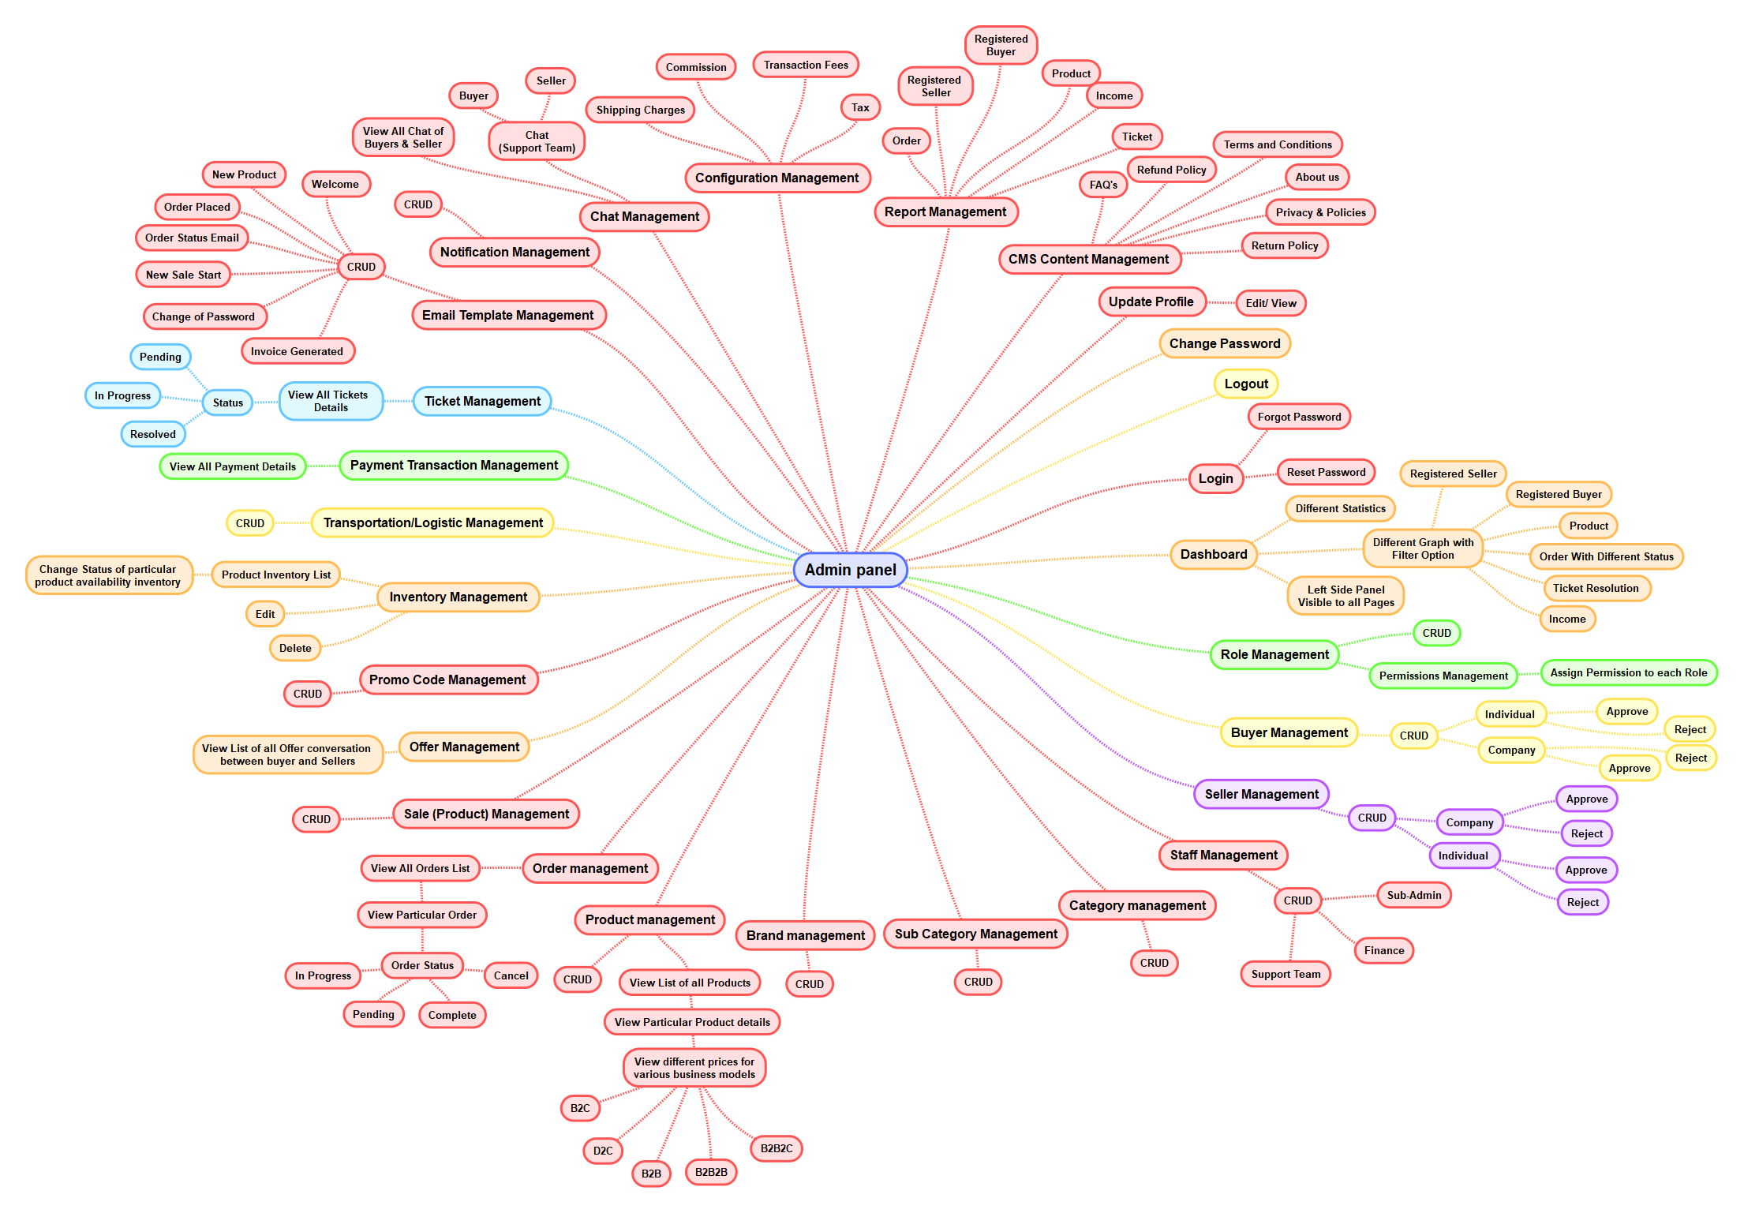

## Magento Admin Panel Management

1. **LOGIN** 
   1. Admin should be able to login into the backend admin panel.
   2. Admin can enter following fields on this Page to login into the backend admin panel:
      1. Email Address
      2. Password
      3. Login button
   3. Admin can view “Forgot password” link on this Page.
   4. **Navigation**:
      1. By clicking on the login button, the system will check credentials and if all credentials are correct then the system will navigate the admin to the “**Dashboard**” Page.
      2. By clicking on forgot password link, the system will navigate the admin to the “Forgot Password” Page.
2. **FORGOT PASSWORD**
   1. Admin should be able to enter their email address to reset their backend credentials.
   2. Admin can enter the following fields on this Page to login into the backend admin panel:
      1. Email Address
      2. Reset Button
   3. **Navigation:** By clicking on the reset button, the system will send an email to the registered email address along with the reset password link. By clicking on the reset password link, the system will navigate the admin to the Reset Password page.
3. **RESET PASSWORD**
   1. Admin should be able to enter required fields to update their backend credentials.
   2. Admin can enter following fields on this Page to login into the backend admin panel:
      1. New Password
      2. Confirm Password
      3. Update Button
   3. **Navigation:** By clicking on the update button, the system will store the updated credentials in the database for the admin account and the system will navigate the admin to the “**Login**” Page.
4. **DASHBOARD**
   1. Admin Buyer can view different statistics on the dashboard as below:
      1. Total Number of Seller
      2. Total Number of Buyer
      3. Total Number of Products
      4. Total Number of Orders
      5. Pending Orders
      6. In-progress Orders
      7. Cancelled Orders
      8. Completed Orders
   2. Admin can view a total number of income for the particular month wise on the dashboard in a graph view
      1. X = Month
      2. Y = Income
   3. Admin can view a total number of order for the particular month wise on the dashboard in a graph view
      1. X = Month
      2. Y = Order
   4. Along with the above details admin can view following menu on left side:
      1. Dashboard
      2. Roles Management
      3. Permission Management
      4. Sub Admin Management
      5. Buyer Management
      6. Seller Management
      7. Category Management
      8. Sub Category Management
      9. Brand Management
      10. Product Management
      11. Sale Product Management
      12. Order Management
      13. Inventory Management
      14. Chat Listing
      15. Chat Detail
      16. Support ticket Management
      17. Notification Management
      18. Email Template Management
      19. Transaction Management
      20. Transportation/ Logistic Management
      21. Config Management
      22. Contact Request Form
      23. CMS Content Management
      24. Offer Management
      25. Promo Code Management
      26. Report
      27. Update Profile
      28. Change Password
      29. Logout
   5. Once admin click on particular menu system will navigate admin to particular associated page.
   6. Dashboard will be display as per the Magento 2 Community Edition Standard and Structure.
   7. We have not consider any type of customization for the Magento 2 Community Edition Dashboard.
5. **ROLE MANAGEMENT**
   1. Admin should be able to view all the roles which has been created by them on this section:
      1. Role (Name)
      2. Option to select permission
      3. Status
         1. Active
         2. Inactive
      4. Actions
         1. View
         2. Edit
         3. Delete
   2. Admin can view Add New Role button above Role listing.
   3. Admin can perform different operations like Create, Read, Update and Delete in this section.
6. **PERMISSION MANAGEMENT**
   1. Admin should be able to set the permissions for different roles wise in this section:
      1. Product (CRUD – Checkbox)
      2. Order (CRUD - Checkbox)
      3. Report (CRUD - Checkbox)
      4. Support Chat (CRUD – Checkbox)
      5. Support Ticket (CRUD – Checkbox)
   2. Admin can update the permission for the particular role in this section.
7. **SUB-ADMIN MANAGEMENT** 
   1. Admin can view all the list of sub-admin that are created by them in this section with below details:
      1. Profile Photo
      2. First Name
      3. Last Name
      4. Email Address
      5. Mobile Number
      6. Actions
         1. View
         2. Delete
         3. Edit
   2. Admin should be able to view create a new sub admin by entering following form fields:
      1. Profile Photo
      2. First Name
      3. Last Name
      4. Email Address
      5. Phone Number
   3. Admin can perform various Operations like CRUD (Create, Read, Update and Delete) on this section as per the Magento 2 Community structure and standard.
8. **BUYER MANAGEMENT**
   1. Admin should be able to view all the list of registered buyer information:
      1. **Normal Buyer:**
         1. First Name
         2. Last Name
         3. Email Address
         4. Mobile Number
      2. **B2B Buyer:**
         1. First Name
         2. Last Name
         3. Email Address
         4. Phone Number
         5. Upload Document
         6. Company Name
         7. Company Logo
         8. Company Address
         9. Company Phone Number
         10. Company Email Address
         11. Country
         12. Phone Number
      3. Admin should be able to verify B2B buyer account through this section.
      4. Once admin will approved or decline B2B buyer account, the system will send an email notification to particular buyer.
   2. Admin can perform various Operations like CRUD (Create, Read, Update and Delete) on this section as per the Magento 2 Community structure and standard.
9. **SELLER MANAGEMENT** 
   1. Admin can view all the list of that are registered into the web platform. with below details:
      1. First Name
      2. Last Name
      3. Email Address
      4. Phone Number
      5. Seller Company Logo
      6. Seller Company Name
      7. Seller Company Email Address
      8. Seller Company Contact Number
      9. Seller Company Address
      10. Document
      11. Selected Type
          1. Saudi
          2. Non- Saudi
      12. Number of people in farm
      13. Year of Established
   2. Admin should be able to review above details and approve or declined the seller registration request.
   3. Once admin approved and declined the registration request system will send an email notification to particular Buyer.
   4. Admin can perform various Operations like CRUD (Create, Read, Update and Delete) on this section as per the Magento 2 Community structure and standard.
10. **CATEGORY MANAGEMENT** 
    1. Admin can view all the list of Category that are published on the web platform in this section:
       1. Category Name
       2. Category Image
    2. Admin can Add a new category by entering the below form fields:
       1. Category Name
       2. Category Image
    3. Admin can update the particular category’s information by clicking on update button/ icon.
    4. Admin can delete particular category from the available list by clicking on delete button/ icon.
    5. Admin can perform various Operations like CRUD (Create, Read, Update and Delete) on this section as per the Magento 2 Community structure and standard.
11. **SUB CATEGORY MANAGEMENT** 
    1. Admin can view all the list of sub category that are published on the web platform in this section:
       1. Sub Category Name
       2. Sub Category Image
    2. Admin can Add a new category by entering the below form fields:
       1. Sub Category Name
       2. Sub Category Image
    3. Admin can update the particular sub category’s information by clicking on update button/ icon.
    4. Admin can delete particular sub category from the available list by clicking on delete button/ icon.
    5. Admin can perform various Operations like CRUD (Create, Read, Update and Delete) on this section as per the Magento 2 Community structure and standard.
12. **BRAND MANAGEMENT** 
    1. Admin can view all the list of sub category that are published on the web platform in this section:
       1. Brand Logo
       2. Brand Name
    2. Admin can Add a new Brand by entering the below form fields:
       1. Brand Name
       2. Brand Image
    3. Admin can update the particular brand information by clicking on update button/ icon.
    4. Admin can delete particular brand from the available list by clicking on delete button/ icon.
    5. Admin can perform various Operations like CRUD (Create, Read, Update and Delete) on this section as per the Magento 2 Community structure and standard.
13. **PRODUCT MANAGEMENT** 
    1. Admin can view all the list of products that are published on the web platform in this section with below details:
       1. Product Image
       2. Product Name
       3. Product SKU Code
       4. Product Category
       5. Product Price
          1. B2B
          2. B2C
          3. B2B2C
          4. B2B2B
          5. D2C
       6. Product Size
       7. Product Color
       8. Product Descriptions
    2. Admin can add a new product by entering the required form fields as above.
    3. Once the admin enter the value of above fields and click on the add product button, the system will add a new product into the system.
    4. Admin can update the particular product’s information by clicking on update button/ icon.
    5. Admin can delete particular product from the available list by clicking on delete button/ icon.
    6. Admin can view the rating and review which given by the Buyer on this section and approve and declined it.
    7. Product management section would be as per the Magento standards and structure.
14. **SALE PRODUCT MANAGEMENT**
    1. Admin can view all list of the product which seller moved for the sale on the platform.
    2. Admin can view product details on this section with below details:
       1. Product Name
       2. Product Category
       3. Product Image
       4. Product SKU Code
       5. Product Price
       6. Product Attributes
       7. Sale Start Date
       8. Salt End Date
       9. Descriptions
       10. Seller Details
           1. First Name
           2. Last Name
           3. Phone Number
           4. Email Address
    3. Admin can perform various Operations like CRUD (Create, Read, Update and Delete) on this section as per the Magento 2 Community structure and standard.
15. **ORDER MANAGEMENT**
    1. Admin can view all the list of orders that are placed by the different Buyer on the platform in this section with the below details:
       1. Order Id
       2. Order Date
       3. Product Name
       4. Product Price
       5. Buyer Name
       6. Buyer Email Address
       7. Buyer Contact Number
       8. Total Number of Quantity
       9. Coupon Code Details
       10. Logistic Provide Details
       11. Total Amount Paid
       12. Status
           1. Pending
           2. In Progress
           3. Completed
           4. Cancelled
    2. Admin can accept or reject the particular order in this section.
    3. Once admin reject the order, the system will send the email notification to the Buyer.
    4. Admin can change the status of the particular order from pending to in progress to on delivery to completed by selecting the particular option from dropdown.
    5. Order management section would be as per the Magento standards and structure.
    6. Admin Should be able to download or print Invoice of the Particular Order from this section.
16. **INVENTORY MANAGEMENT**
    1. Admin should be able to view and manage product inventory through this section.
    2. Admin can view each product wise stock on this section.
    3. Once order is placed on the frontend web platform for a particular order, then particular number of quantity will be deducted or decreased for a particular product.
    4. Admin should be able to view inventory after placing an order by buyer, admin can view the stock availability on this section. Seller can track the location, amount, pricing available from their business.
    5. Admin should be able to view and manage the following things:
       1. Stock Availability
       2. Product Quantity
       3. Inventory Configurations
    6. Inventory management section would be as per the Magento standards and structure.
17. **CHAT LISTING PAGE**
    1. Admin should be able to view all list of seller/buyer that they have chatted previously in this section, with below details:
       1. Seller/ Buyer Profile Photo
       2. Seller/ Buyer Name
       3. Seller/ Buyer Status
          1. Online
          2. Offline
       4. Last message
       5. Last Message Received Date & Time
    2. **Navigation:**
       1. Once admin click on particular seller/buyer, the system will navigate buyer to the Chat Detail page.
18. **CHAT DETAIL PAGE** 
    1. Admin should be able to communicate with the particular seller/buyer through this page.
    2. Admin can view and previous chat with the particular seller/buyer in this page:
       1. Seller/ Buyer Profile Photo
       2. Seller/ Buyer Name
       3. Seller/ Buyer Status
          1. Online
          2. Offline
       4. All Chat Messages
       5. Chat Input Box
          1. Through this section, admin can only send a text messages to the seller.
    3. **Note**:
       1. For the chatting functionality, we will integrate the Google Firebase chat into the application.
       2. Client will provide all the details regarding to the Google Firebase Chat.
       3. We have not consider Image, Document, file, GIFs, Video sending functionality for the chat features.
19. **SUPPORT TICKET MANAGEMENT**
    1. Admin should be able to view all the tickets which has been created by different buyer and seller on this section with below details:
       1. Ticket Number
       2. Issue Type
       3. Ticket Title
       4. Buyer/ Seller Details
          1. First Name
          2. Last Name
          3. Phone Number
          4. Email Address
       5. Ticket Description
       6. Created Date
       7. Current Status
          1. Pending
          2. In Progress
          3. Resolved
    2. Admin should be able to change the ticket status on by selecting particular option from the dropdown.
    3. Once admin change the status of particular ticket, the system will send an email notification to particular seller and buyer.
    4. Support ticket management section would be as per the Magento standards and structure.
20. **NOTIFICATION MANAGEMENT**
    1. Admin should be able to view all the notification that they have send to all the buyer/Seller with below details:
       1. Notification Title
       2. Notification Description
       3. Send Date
       4. Send Time
       5. Total Number of Read
    2. Admin can send a notification by entering required form fields:
       1. Notification Title
       2. Notification Description
       3. Send to
          1. Checkbox for “All Users”
          2. Checkbox for “Buyer”
          3. Checkbox for “Seller”
       4. Send Button
    3. Once admin enters value of above fields and click on send button, the system will send a notification to the particular users based on the admin selection.
21. **EMAIL TEMPLATE MANAGEMENT**
    1. Admin should be able to view all email template that they have created on this section.
    2. Admin should be able to manage email template through this section, as follow:
       1. Welcome (Registration)
       2. New Product
       3. Order Placed
       4. New Sale Start
       5. Change of Password
       6. Invoice Generated
    3. Admin should be able to manage all the email template through this section.
    4. Admin can do the various activity such as add, read, update and delete (CRUD Operation).
    5. Email template management section would be as per the Magento standards and structure.
22. **TRANSACTION MANAGEMENT**
    1. Seller should be able to view all the transaction which buyer did on the platform on this section with below details:
       1. Transaction ID
       2. Transaction Date & Time
       3. Product Name
       4. Product Category
       5. Number of Quantity
       6. Seller Information
          1. Full Name
          2. Email Address
          3. Phone Number
          4. Address
       7. Amount Paid
       8. Seller Profit Amount
23. **TRANSPORTATION/LOGISTIC MANAGEMENT**
    1. Admin should be able to managed logistic provider details through this section.
    2. Admin can view their added logistic providers details on this section with below details:
       1. Logistic Provider Name
       2. Logistic Provider Logo
       3. Logistic Provider Address
       4. Charge
       5. Delivery Time
       6. Created Date
       7. Action
          1. View
          2. Edit
          3. Delete
    3. Admin should be able to do various activity such as create, read, update and delete on this section as per magento standard and structure. (CRUD Operation)
24. **CONFIG MANAGEMENT**
    1. Admin can set the following Config setting for each category separately in this section as below:
       1. Shipping Charges
       2. Commission Amount/Percentage
       3. Transaction Fees
       4. Tax
25. **CONTACT REQUESTED FORM**
    1. Admin can view the following below details on this section:
       1. First Name
       2. Last Name
       3. Email Address
       4. Your Phone Number
       5. Subject
       6. Message
       7. Submitted date & Time
       8. Reply Button
    2. Once admin click on reply button, the system will open a popup box in which admin have to enter the reply. Once admin enter the reply and click on send button, the system will send an email notification to particular buyer.
    3. Contact requested form would be managed as per magento standard and structure.
26. **CMS CONTENT MANAGEMENT**
    1. Admin should able to manage the following below content:
       1. FAQ's
       2. Terms and Conditions
       3. Privacy & Policies
       4. Return Policy
       5. Copyright text
       6. About us
       7. Contact us
    2. Admin can perform the CRUD (Create, Update, Delete, and Read) functionality on this section as per magento standard and structure.

1. **OFFER MANAGEMENT**
   1. Admin should be able to view all the offers and counter offers conversation details which buyer and seller did on the platform on this section, with below details:
      1. Buyer & Seller Details
         1. First Name
         2. Last Name
         3. Email Address
         4. Phone Number
      2. Product Name
      3. Product Category
      4. Buyer Price
      5. Seller Price
      6. Number of Quantity
      7. Date & Time
   2. Offers would be managed as per magento standard and structure.

1. **PROMO CODE MANAGEMENT**
   1. Admin can view all the list of promo code that are created by themselves
   2. Admin can create a new promo code by entering the following form fields:
      1. Promo Code Name
      2. Promo Code Description
      3. Promo Code
      4. Promo Code Expiry Date
      5. Discount Type
      6. Flat
      7. Percentage
   3. Admin can update the particular Promo code’s information by clicking on update button/ icon.
   4. Admin can delete particular Promo code from the available list by clicking on delete button/ icon.
   5. Admin can do various activity such as create, read, update and delete.
   6. Promo code management would be as per the Magento standards and structure.
2. **REPORT** 
   1. Admin can download the report through this section:
   2. Admin should be able to download following report through this section:
      1. Order
      2. Registered Seller
      3. Registered Buyer
      4. Product
      5. Income
      6. Ticket
   3. Custom Date Range: Once admin click on this option, the system will display two fields as below:
      1. Start Date
      2. End Date
   4. Once admin select the start date and end date using the calendar and click on the report button, the system will generate a particular reports based on the selected date and display the data to the admin on this section.

1. **UPDATE PROFILE**
   1. Admin should be able to view and update their backend admin panel profile details through this section.
      1. First Name
      2. Last Name
      3. Email Address
      4. **Update Button:** By clicking on update button, the system will store all data into the database into particular admin account that are updated by the admin and display a toast message “Profile Updated Successfully” To the admin.
2. **CHANGE PASSWORD**
   1. Admin should be able to change their backend admin panel account credentials through this page.
   2. Admin can enter the below fields to update their backend admin panel credentials:
      1. Old Password
      2. New Password
      3. Confirm Password
      4. **Update button:** By clicking on it, the system will store credentials into the database into particular admin account that are updated by the admin and display a toast message “Password Updated Successfully” to admin.

**Note:**

* **All the content and images that are required for the web platform will be provide by clients.**
* **Responsive Frontend web platform will be develop as per the HTML structure and standard**
* **All the 3rd party plugin or extension or library that are required for the web platform development will purchase by the client and provide us with all the necessary details.**
* **Backend Magento admin panel will be as per the Magento standard and in English language only.**
* **All the 3rd party plugin or extension or library that are required for the application development will purchase by the client and provide us with all the necessary details.**
* **Notification sending functionality from the backend admin panel will work as per the Magento 2 Community Editions structure and Standard.**
* **We will integrate PayPal, STC Pay, Sadad, Apple Pay payment integration into the system, all the necessary details will be provided by client.**
* **We will create an excel Sheet for all the English Labels. All the Arabic language label translation will be provided by the client in an Excel Sheet. Data that is entered will be display as it on the mobile application & Web Platform when the language selection activity performed by any user.**
* **We have not considered any 3rd party shipping integration in current phase.**
* **We assume that admin will send seller earning amount outside of the platform.**

# Team Details

|  |  |  |
| --- | --- | --- |
| **PROFILE** | **NO OF RESOURCES** | **EXPERIENCE** |
| Project Lead | 1 | 8+ Years |
| UI/UX Expert | 1 | 6+ Years |
| Sr. iOS Developer | 2 | 5+ Years |
| Sr. Android Developers | 2 | 5+ Years |
| Magento Developers | 2 | 6+ Years |
| Quality Analyst | 1 | 5+ Years |
| Total Team Size | **9 Resources** | |

# Deliverables

|  |  |
| --- | --- |
| **PROJECT MANAGEMENT** | Pro-active consultation |
| SCRUM based execution |
| **DESIGN** | Custom iPhone & Android Design as per Apple’s and Google marketplace standard |
| Custom Web Design |
| Responsive HTML (Mobile & Tablet Friendly) |
| **MOBILE APPLICATION DEVELOPMENT** | Native iPhone Mobile Application Development |
| Native Android Mobile Application Development |
| **WEBSITE DEVELOPMENT** | Website Development |
| **BACKEND DEVELOPMENT** | Database Design |
| Rest API Development |
| Super Admin Web Panel Development |
| **QUALITY ASSURANCE** | Manual Unit Testing |
| Adhoc Testing |
| **VALUE ADDED SERVICE** | App Submission to Apple Store for iOS version |
| Web Platform Deployment on client’s server |
| Deploy REST APIs on client’s server |
| 3 Months Post deployment Warranty (for any bugs/ errors) |
| **DEPLOYMENT** | Client will provide ready server for CMARIX team to deploy. |

# Warranty

|  |  |
| --- | --- |
| **Warranty Period** | 3 Months Post deployment Warranty (for any bugs/ errors) |

As a part of this proposal, CMARIX will provide above Warranty Period – which applies immediately post deployment including unlimited support for fixing any bugs or error based on the defined scope of work.

Any changes made to code or server by anyone other than CMARIX will lead to void of warranty. Thereby, corresponding fixes will not be covered under the warranty coverage.

Warrant coverage is only for fixing any bugs / errors. It does not cover any changes, feature addition or any out of scope items.

# Maintenance Service Contract

Service is more important than sales. At CMARIX, we firmly believe this and take pride in providing ongoing maintenance service to our customers. Following are different Maintenance Service packages to suit your business needs:

|  |  |  |  |
| --- | --- | --- | --- |
| **Duration** | **Per Hour Rate** | **Hours** | **PRICE (USD)** |
| 3 Months |  | 50 |  |
| 6 Months |  | 100 |  |
| 12 Months |  | 200 |  |

Maintenance Contract is highly recommended for any software platform to ensure smooth operations.

CMARIX - Maintenance services include fixing bugs, implementing changes as well as feature addition. We strongly recommend client - to not give code access or rights to make code changes to anyone other than CMARIX during this maintenance period.

# Commercial Terms

## Price & Timeline

|  |  |
| --- | --- |
| **PROJECT PRICE** | $ USD |
| **TIMELINE** | Around weeks |

## Milestone

|  |  |  |  |
| --- | --- | --- | --- |
| **#** | **MILESTONE** | **AMOUNT IN %** | **AMOUNT IN USD** |
| **1** | Award of Project | 20% |  |
| **2** | After Design confirmation | 20% |  |
| **3** | Web Platform Initial Demo | 20% |  |
| **Design Integration**   * Integrate the design in the Mobile App with Static Data * Design Flow with Complete Navigation | 20% |  |
| **4** | After Final Demo | 20% |  |
|  | Total | 100% |  |

## Payment Mode

|  |  |  |
| --- | --- | --- |
| **OPTION #** | **PAYMENT METHOD** | **NOTES** |
| **1** | Wire transfer | Additional $40 USD fees would be applied/ Invoice |
| **2** | PayPal | Additional 5.5% PayPal fees would be applied/ Invoice |

# Technology Stack

**WEB PLATFORM DEVELOPMENT**

|  |  |
| --- | --- |
| **PLATFORM** | **SPECIFICATION** |
| **OPERATION SYSTEM** | Linux |
| **WEB SERVER** | Apache 2.x |
| **DEVELOPMENT ENVIRONMENT** | Magneto 2.x Community Edition + MySQL |

**FRONTEND BROWSER COMPATIBILITY**

|  |
| --- |
| **SUPPORTED BROWSER** |
| Google Chrome (Latest Version) (Windows, MAC Desktop, Mobile, iPad & Tablet) |
| Firefox (Latest Version) (Windows, MAC Desktop, Mobile, iPad & Tablet) |
| Safari (Latest Version) (MAC Desktop, Mobile, iPad & Tablet) |
| Microsoft Edge (Latest Version) (Windows, Mobile, iPad & Tablet) |

**FRONTEND RESPONSIVE BROWSER COMPATIBILITY**

|  |  |
| --- | --- |
| **SUPPORTED BROWSER** | |
| 1900 X 1200 | 1366 X 768 |
| 1024 X 768 | 1024 X 1366 |
| 1280 X 800 | 414 X 736 |
| 375 X 667 |  |

**PLATFORM SUPPORT FOR MOBILE APP**

|  |  |  |
| --- | --- | --- |
| **PLATFORM** | **IOS** | **ANDROID** |
| **OS VERSION** | iOS 13.x to 15.x | Android 9.x to 12.x |
| **DEVICE TYPE** | **iPhone** iPhone 13 Pro, iPhone 13 Pro Max,  iPhone 13, iPhone 13 mini  iPhone 12 Pro, iPhone 12 ProMax, iPhone 12, iPhone 11 Pro,  iPhone XS, iPhone XS Max,  iPhone XR, iPhone X,  iPhone 8 Plus, iPhone 8 | Android Mobile** |
| **LANGUAGE** | Swift 5.x | Kotlin |
| **ORIENTATION** | Portrait | Portrait |

**\*\*ANDROID MOBILE RESOLUTIONS**

|  |  |
| --- | --- |
| **ANDROID MOBILE RESOLUTIONS** | |
| 1440 X 3040 | 1440 X 2930 |
| 1440 X 2880 | 1440 X 2560 |
| 1080 X 2160 | 1080 X 1920 |
| 320 X 240 |  |

# Our Portfolios

## Mobile Application

## Web Platform

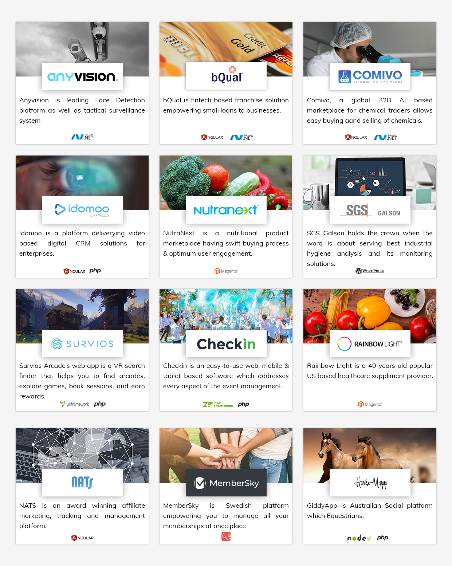

# Our Certification

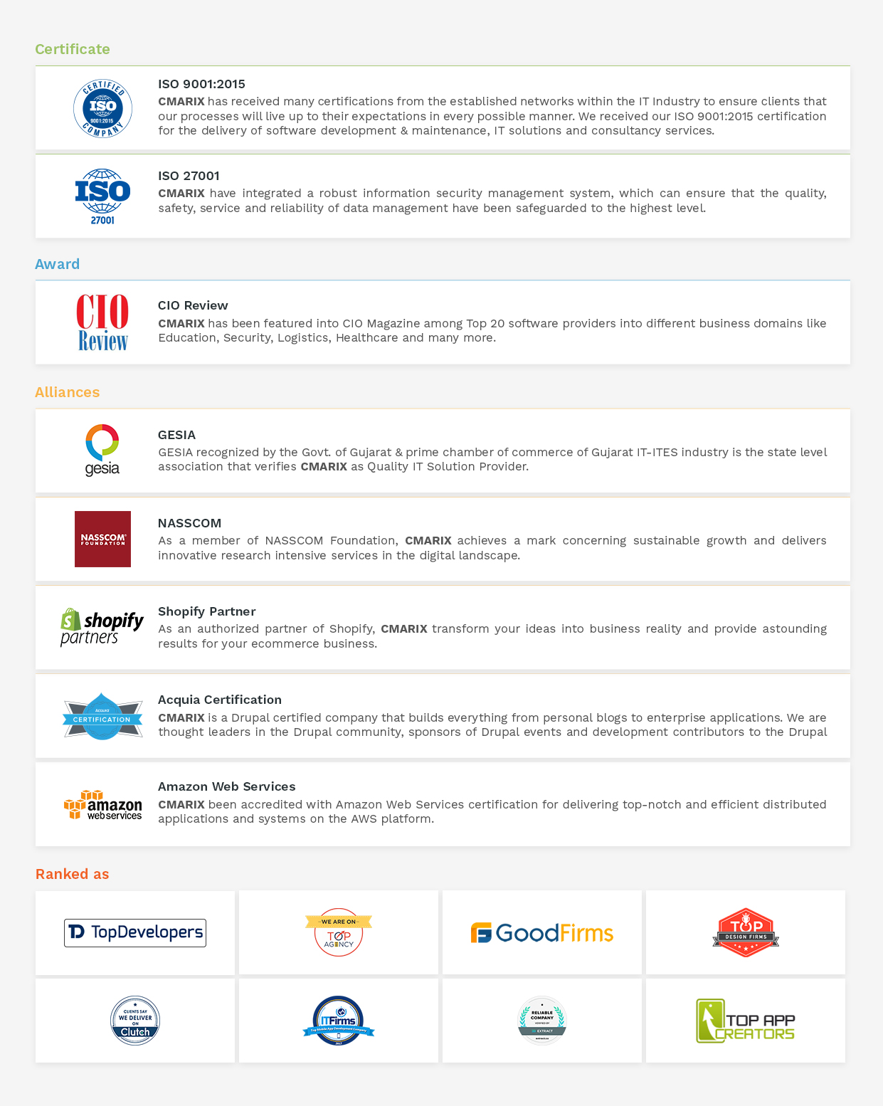

# Our Valuable Clients

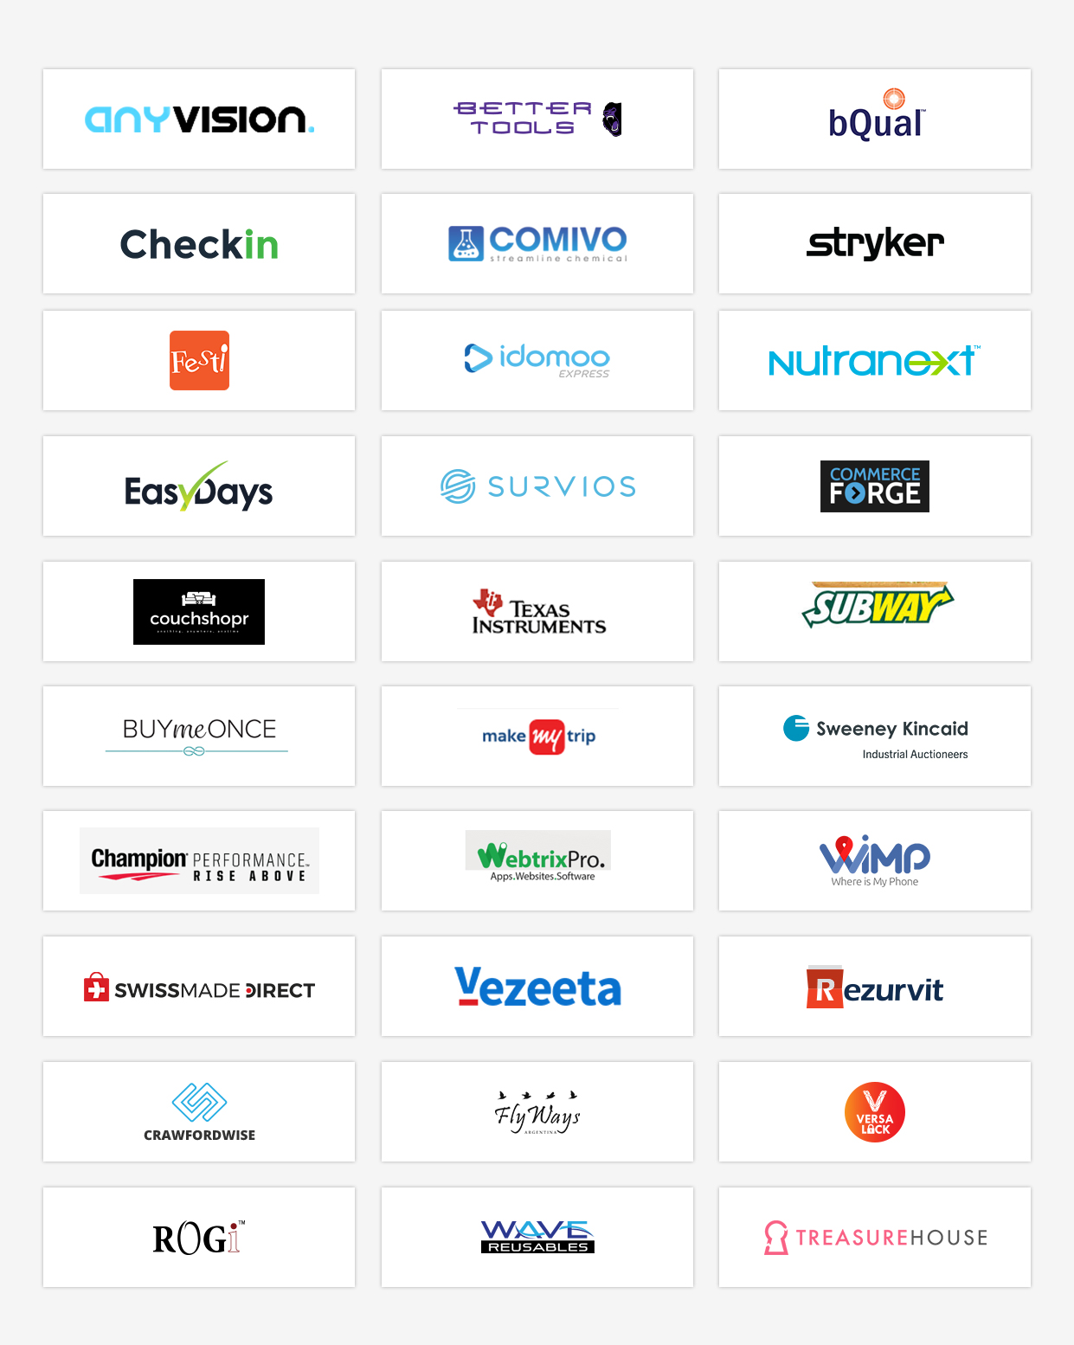

# Change Request Management

CMARIX will be happy to accommodate any additional features or functionality using the Change Request Management Process, whereby we will outline the task list & provide corresponding time & cost estimation for the same. Based on client’s approval we will implement the same. Any item which is not included in current scope of work would be part of change request management process.

1. **Definition of Change Request:**

Any features or functionality which are not part of confirmed project proposal.

Any changes in features or functionality once the design is confirmed & development has started.

1. **Definition of Add-ons:**

Addition of any new feature or functionality which is not part of confirmed project proposal.

# Exclusion

Following items are NOT included in the given proposal and clearly excluded.

1. **Development of Detailed Technical Functional Specification**

Detail functional specification is not included in this proposal execution. Scope document will be the base document for the requirements.

1. **Out of Scope**

Any and all features which are NOT defined in the scope of work of this document will be out of scope and can be implemented as per standard Change Request Management process, if required.

# Assumption

We have considered below assumptions while working on current understanding.

|  |  |
| --- | --- |
| **TOPIC** | **ASSUMPTION** |
| **DESIGN** | We will create a design for the Frontend Responsive Web Platform and iPhone and Android Application Design as per the Apple and Google Market standard and structure.  App will get designed and developed in either **“Light mode”** OR **“Dark mode”** for the iOS Version. |
| **MULTILINGUAL** | The Native iPhone and Android Application and web platform will support the **“English & Arabic”** language only. Magento Admin Panel will be in English language only. |
| **3RD PARTY TOOL** | Customer will need to buy/purchase a license for any pre-approved 3rd party tools/extension/API which is going to be integrated into the Web Platform and mobile application. |
| **CONTENT** | We assume that entire Static CMS Content-related to the web platform and Native iPhone & Android Application will be provided by the client. Content means text, images and other assets. |
| **DOCUMENTATION** | CMARIX has not considered the development of any documentation on this Project. In the case of an additional request, CMARIX can provide charges separately. |
| **DEPLOYMENT** | For Deployment, we assume the client will provide  - cPanel detail with full access  - PhpMyAdmin with full access  - The domain should be pointed to the server  - Full FTP access  - Pre-installed SSL certificate on Server (if applicable)  - Apple & Play store developer account to launch the application |
| **DATA ENTRY** | Data Entry and Data Migration Services is not included in the current scope of work. We can provide this as an additional services, if required. |
| **ANIMATION** | Animation of any kind is not included in the current scope of work. |

# Ownership

In consideration of and effective upon CMARIX receipt of all payments required hereunder with respect to a specific Application, and provided that Customer is not otherwise in material default of any provision of this Agreement or any Project Appendix, CMARIX acknowledges and agrees that Ownership of the complete product will belong to the customer. In consideration of and effective upon CMARIX receipt of all payments required hereunder, CMARIX hereby grants to Customer exclusive, transferable license, with the right to sublicense, to use, copy, operate software created by CMARIX.

## Publicity

Upon Customer's prior written consent in each instance, CMARIX may use Customer's logo and trademarks, and any work produced for the Customer by CMARIX, for promotional use both in printed and online portfolio formats, provided that no such disclosure shall result in the breach of CMARIX confidentiality obligations under this Agreement.

## References

CMARIX may refer to the Services performed under this Agreement and to CMARIX relationship with Customer without disclosing Confidential Information in resumes and experience/qualification summaries; provided, that such resumes and summaries shall not suggest that Customer endorses or recommends CMARIX work without Customer's prior consent.

# Project Management Approach

## Introduction

Project Management activity is an umbrella activity that will span the entire project lifecycle. Our Project Management processes are based on the PMBOK ® knowledge areas & SCRUM based Agile Execution.

***Initial Kick-off Meeting:***

A project "kick-off" meeting with the Client team would signify the start of the project. A project manager is designated to manage the project, CMARIX Team of designers, developers and QA engineers.

Client would also designate a one-person coordinator who interacts with our team on all aspects of implementation and takes all relevant decisions with regard to the implementation of the system. We strongly recommend there to be single point of contact from client for effective collaboration.

Project Purpose and Scope, Client Information and Client’s Expectations, Delivery schedule with associated milestones and financials, Roles and Responsibility Definition, Details of the First milestone, General Coding Guidelines, third-party integrations, Client dependency sheet and assumptions, Major Risks and Process Tailoring are discussed during project kickoff and documented in Project Initiation Note.

***Project Planning and Work Allocations:***

The purpose of the Software Project Planning is to establish reasonable plans for performing the software engineering tasks and for managing the software project. We possess expertise in using diverse Project Management tools for project scheduling and tracking which covers tracking and scheduling through Gantt Charts and other industry standard tracking techniques. Apart from using tools like Trello, Jira, Basecamp, and Asana for planning and scheduling, we also use our in-house Intranet Application for project execution. Allocations are done using this application against which each resource fills up daily time sheets listing the activities done during the day.

A comprehensive Project plan is prepared, which outlines all the critical aspects related to the smooth project execution. These include:

* General Planning and Milestones
* Scope Management
* Team formation and Engagement
* Integration Planning
* Communication Planning
* Quality Management
* Risk Management and Mitigation
* Tracking and Control

## Project Monitoring and Tracking

When the project is initiated, the team has communicated the details of the project along with its milestones. Details of each milestone are clearly communicated across the team to ensure that everyone is aware of the entire project timeline.

Once the project starts, in the planning phase itself, we will outline the Quality Plan. All the activities, work-product reviews, and inspections that aim quality will be outlined in the quality plan. Quality plan will be reviewed/approved and will be kept at the central point of access. Project Manager keeps a tab on all the quality related activities throughout the project execution to ensure that the project meets the specified quality requirements.

Dedicated SQA member(s) take care of all the incremental and functional testing. SQA will also ensure that the defined processes are followed in the project.

Project will closely be tracked against the established plan and any deviations therein will be promptly reported to the client along with the suggested corrective actions.

The planned v/s. actual progress is tracked by Project Manager periodically to ensure that the project abides by the established timeline. It also enables Project Manager to keep Client’s abreast of the progress of the project on a periodic basis.

Project status reviews are done internally with the team periodically (E.g.: Weekly, Fortnightly etc. as agreed). Project status meetings and updates to Client will be given using the Project Status Review document. The status of ongoing work will also be given to Client by demonstrating the ongoing work through collaborative tools like GoToMeeting.

|  |  |  |
| --- | --- | --- |
| **ACTIVITY** | **PROCEDURE** | **TOOL USED (IF ANY)** |
| Scheduling | The Project Manager would perform scheduling and re-scheduling. The team members will be assigned their tasks by PM and the module leaders (if any) | The work allocation will be prepared in an excel sheet and the same will be communicated to the concerned persons. |
| Project Meeting (Internal) | Periodical internal meetings. Both technical and managerial aspects would be discussed. Minutes of Meetings would be recorded and tracked. | NA |
| Status Review Meetings  With Senior Management  With CLIENT | Periodical Project Status Review Meetings with senior management. Minutes of Meetings would be recorded and tracked.  Ad-hoc meetings would be held to resolve any issues. | NA |

**Tracking of Issues**

|  |  |  |  |
| --- | --- | --- | --- |
| **ISSUE TYPE** | **PROCEDURE** | **LEVELS** | **ESCALATION PROCEDURE** |
| Project Internal issues & Support Issues | Internal issues of the project would be resolved during the periodical internal meetings. Project Manager and Module Leader together are responsible for resolving or escalating such issues. | Level 1 | If the internal issues are not resolved within 3 working days, the issue would be escalated to Escalation Manager. |
| Customer Issues | Customer will be updated by Project Coordinator from CMARIX to Customer.  The change requests will be sent by the customer to the PM | Level 2 | If the issues are not resolved within 7 working days, the issue would be escalated to Delivery Manager |

## Communication

We proposed the following guidelines to be used for documentation and communication for effective project management.

* Any transfer of the documentation from either side will be done in MS Word, PDF or MS Excel sheets in soft copy formats via electronic media. Document standards will be made available. All the documents should be in the English Language.
* The project team will review progress at the regular weekly staff meetings
* CLIENT and CMARIX will briefly talk every week to assess the overall progress of the project and issues that may be impeding its movement
* Modes of communication
  1. Slack / Skype
  2. Google Meet / Zoom
  3. Email
* Frequency of Communication
  1. Daily (Depending on the sprint planning)
  2. Weekly Peer Reviews
  3. Client Meeting [fortnightly]
* Complete Contact information of the Project Managers from either side will be made available at the start of the project
* Stakeholders Responsible for communication
  1. Project Manager, CMARIX
  2. Project Manager, CLIENT
* Finalization of ongoing Intermediate Communication
* Minutes of Meeting to be signed off by Project Managers

# Term And Condition

**DISCLAIMER:**

* CMARIX follow all its communication and documentation in English language only.
* CMARIX may display the project on its portfolio as well as other partner sites after successful completion of work.
* In the case of any Projects which are under confidential agreements, CMARIX will only use Logo of the Project for display/marketing purpose.

**PRICE and PAYMENT TERMS:**

* Submitted Proposal Estimation is valid for 15 days from the date of proposal sent, In case of any approvals after 15 days are subject to reconfirm with CMARIX business team
* Cost of infrastructure, hardware, server software and network required at customer’s end are excluded from CMARIX proposition.
* CMARIX proposition does not include any costing of additional services such as domain registration, hosting, payment gateway or any third party charges.
* In the case of any emergency closure/termination of the project requested by the customer, CMARIX will seek payment for the work done till date as per resources engaged in Project before we treat project as CANCELLED or CLOSED.
* CMARIX will NOT provide any refunds to the customer.
* While making payment, the purpose of payment should be “Web/ Mobile Development Charges”.
* Client will have to provide necessary signed documents required for accounting purpose in accordance with this proposal.
* Payment needs to be cleared within 5 days of Performa invoice received by the company.
* Client has to make the payment as per the payments terms mentioned in the proposal.

**SCOPE:**

* Company Logo creation/development will not be a part of the Project development unless agreed as a part of scope section.
* Any change request from a customer while execution of the Project after wireframes and designs approval stage will go through Change Request Process as defined earlier in this Proposal document.
* Data migrations from Old Projects/Application to new Site/Application are out of scope unless defined as part of scope section.

**PAYMENT MILESTONES:**

* *Award of Project Milestone* refers to the first payment milestone requested as a formal approval of the project. Once client provides this CMARIX will plan team allocation and finalize the start date of the project.
* *Design Confirmation* *Milestone* refers to the payment that needs to be processed by the client when the designs provided by CMARIX are finalized. Once payment of this milestone is made, project execution plan will be provided and project development will start.
* *Design Integration Milestone* refers to the frontend design integration in the application. In this milestone only design integration is completed and shared with client. Client can click on each and every elements (i.e. buttons, images, links, animation) and can see or navigate to respective screens. This demo doesn’t include any kind of development/ programming. It will be a clickable design.
* *Initial Demo Milestone* refers to the work-in-progress demo provided to client. Please note that no feedback, quality check or client review is required on this milestone as its work in progress. Demo details for this milestone will be defined by the Project Manager in the detailed project plan.
* *Final Demo Milestone* refers to the final payment that needs to be processed by the client when final demo is provided by CMARIX. This demo will be provided on CMARIX staging server ONLY. Once corresponding payment is made, than CMARIX will proceed forward with delivery of the source code and launch.
* CMARIX accounts will raise invoice when corresponding milestone is achieved. Payment should be made within 5 working days of the invoice date. In case there is delay in payment of more than one week, than CMARIX will put the project officially ON HOLD.
* Once the project is ON HOLD additional 10% cost of the entire project will be added up in a final milestone of the project payment, considering the bench cost, additional overhead of resource allocation / de-allocation etc.

**ESTIMATION:**

* CMARIX has provided this Proposal based on business understanding and scope defined by customer till date. At the time of requirements analysis and design / wireframe stage if any major is risk identified it will be shared with the customer and revised efforts in terms of time and cost will be submitted for approval before going into next step of SDLC.
* Provided estimation does not include any data entry, content writing or templates creation work.
* It is client’s responsibility to ensure they have revised the detailed scope of work based on which estimation is provided.

**RESOURCES UTILIZATION:**

* CMARIX assumes that customer would provide one project manager and functional expert(s) during Requirement Analysis and Knowledge Acquisition phase.
* CMARIX do not have any control on third-party software or vendors, so the customer will have to take care of the complete responsibility for any third party vendor’s dependency or faulty products and consequences arising out of such usage.

**PROJECT AND CODE DELIVERY:**

* This is a Fixed Cost Proposal for which source code delivery will be provided AFTER the final demo and final payment milestone is cleared by client. Source code will be delivered once 100% payment is made.
* CMARIX does NOT keep backup of client’s project once delivered. Once project is delivered it is client’s responsibility to keep back of the project code and corresponding assets.

**TIME BOUND CLAUSES:**

* CMARIX assumes that all sign-offs from customer will be provided within agreed and specified timeframe. Such time frame can be decided at the beginning of each key milestone/activity between customer and development team.
* It is requested that the customer will provide confirmation/approval for requested stages as & when required within 2-3 business days. It is expected that Client will resolve queries in reasonable time frame. Any delay can result in slippage of the schedule agreed.
* In case if there no response or a delay from a client with regards to the response to queries or feedback which affects to the overall planning of the Project and resources sitting idle, longer than a week, than the project will be put ON HOLD and additional 10% cost of the entire project will be added up in a final milestone of the project payment.
* For any circumstances, if the project needs to be put on Hold by either party (customer or developer) it requires minimum request notice period of 1 week along with duration for how long this has to be kept on HOLD. In both cases the request will be addressed by CMARIX management and final conclusion will be made.
* CMARIX will require a lead-time of the 1-2 week to start the project after the project is awarded.
* In case customer requires any extension or delay on the proposed acceptance schedule, the associated effort and cost of such extension can be mutually agreed if needed.

## Terms of Acceptance

These General Terms and Conditions and all Project Appendices constitute the entire agreement between the parties and supersede all previous negotiations, agreements, and other communications, whether oral or written, relating to the subject matter of this Agreement. Any variance from or addition to the terms of this Agreement contained in any purchase order or other written notification will be of no effect. This Agreement may not be assigned by either party without the prior written consent of the other, except for assignments to affiliated entities or to a successor company whether by merger, acquisition or a sale of substantially all of the party's assets. This Agreement may not be modified in any way except in writing signed by both parties. This Agreement shall be governed in all respects by the laws of the states of Gujarat, India. The invalidity or unenforceability of one or more provisions of this Agreement shall not affect the validity or enforceability of any of the other provisions, and this Agreement shall be construed in all respects as if such invalid or unenforceable provisions.

**SIGNED BY THE PARTIES OR THEIR DULY AUTHORISED REPRESENTATIVES**

|  |  |  |
| --- | --- | --- |
| **CUSTOMER POINT OF CONTACTS** | **FIRST CONTACT** | **ALTERNATE CONTACT** |
| **FULL NAME** |  |  |
| **COMPANY NAME** |  |  |
| **DESIGNATION** |  |  |
| **DATE** |  |  |
| **SIGNATURE** |  |  |

# Acceptance Criteria and Procedure

Client will perform acceptance testing of the deliverables on their systems. CMARIX team will assist the acceptance-testing phase. Any issues reported during the Acceptance Testing will be analyzed and categorized as "Defects" or "Change Requests (CRs)". Problems arising due to the defects in the realization from the starting points will be categorized as Problem Reports and rectified by CMARIX. CMARIX will attempt to solve the problems reported at the earliest. In case the estimated time for solving the problems is going to be significant, it will be communicated to the Client.

**Formal Acceptance Testing** will start after CMARIX sends the final delivery. CMARIX will make out a formal Delivery Note to the Client. Client will acknowledge, review the work and approve the delivery as complete and acceptable or incomplete and unacceptable, within the number of days of delivery being made as mentioned below. If rejected, CMARIX will rework the software to requirements.

The scheduled acceptance period, for the completed delivery, would depend on the release.

CMARIX uses following defect classification:

|  |  |
| --- | --- |
| **TYPES** | **DESCRIPTION** |
| P0 | Fatal Error. A runtime error occurs which causes the application to crash. |
| P1 | No Fatal Error, but functionality differs from the specification. |
| P2 | Error wherein the software works but a degree of inconvenience is caused. Correction is not deferrable and an easy workaround exists. |
| P3 | Cosmetic errors like navigational errors, object positioning on the screen etc. |

CMARIX will fix all P0 and P1 defects reported during acceptance. Conditional Acceptance will occur for P2, and P3 defects. A defect will be treated as "fixed" once the problem identified in the defect report is corrected and Client verifies the correction.

All project deliverables included as part of the final deliverable of each will be "Deemed Accepted", if no errors have been reported or if no communication to any effect is received from Client within 7 calendar days after the final deliverables. CMARIX will notify Client via e-mail that the deemed acceptance has occurred.

